ENVIRONMENTAL AND SOCIAL IMPACT ASSESSMENT OF THE PROPOSED CONSTRUCTION OF ONGATA RONGAI TO KITENGELA TARMAC ROAD

GROUP 1 FIELDWORK ASSIGNMENT

|  |  |  |
| --- | --- | --- |
| NAME | REFERENCE NUMBER | REGISTRATION NUMBER |
| SAMUEL GACHUHI NGUGI[1] | EIA 2020/016 | 21J01EIA013 |
| CYNTHIA WAMUKOTA | EIA 2020/041 | 21J01EIA032 |
| ERIC NYABUTO | EIA 2020/021 | 21J01EIA024 |
| IAN NJATHI | EIA 2020/027 | 21J01EIA018 |
| PERIS MAINA | EIA 2020/035 | 21J01EIA016 |
| HUDSON ALUVANZE | EIA 2020/025 | 21J01EIA015 |

Contents

Executive Summary 7

1. INTRODUCTION 19

1.1. Project description 19

1.2. ESIA Objectives 19

1.3. Objectives of the road 19

1.4. Scope of the work 20

1.5. Project Proponent 21

1.6. Project Design 21

2. BASELINE SURVEY 23

2.1. Introduction 23

Baseline data collection methods 24

2.2. Physical Environment 24

Topography 24

Geology 24

Climate 25

Hydrology 25

Soils 26

2.3. Biological Environment 28

Vegetation 28

Animals 28

2.4. Socio-economic Environment 29

Population 29

Land use 29

Livelihood 29

Real Estate 29

Infrastructure & amenities 29

3. POLICY, LEGAL AND INSTITUTIONAL FRAMEWORK 31

3.1. Introduction 31

3.2. National Policy Framework 31

Kenya Vision 2030 32

National Environmental Action Plan (NEAP) Guidelines of 2016 32

The Poverty Reduction Strategy Paper (PRSP) of 2000 32

Sessional Paper No.10 of 2014 on The National Environment Policy 33

The National Biodiversity Strategy of 2019 33

The Land Policy (2017) 34

Wildlife Policy of 2020 34

Wetlands Policy of 2013 34

Physical Planning Policy 35

Public Health Policy of 2014 35

HIV/AIDS Policy of 2009 35

Gender Policy of 2011 35

The Kenya National Climate Change Response Strategy of 2010 35

3.3. National Environmental Legal Framework 35

The Constitution of Kenya of 2010 36

Environmental Management and Coordination Act No 8 of 1999 36

Environmental Management and Co-ordination (Environmental Impact Assessment and Audit) Regulations, 2003 37

Environmental Management and Co-ordination (Water Quality) Regulations, 2006 37

Environmental Management and Co-ordination (Fossil Fuel Emission Control) Regulations, 2006 37

Environmental Management and Co-ordination (Conservation of Biological Diversity and Resources, Access to Genetic Resources and Benefit Sharing) Regulations, 2006 37

Environmental Management and Co-ordination (Waste Management Regulations, 2006) 38

Environmental Management and Co-ordination (Controlled Substances) Regulations, 2007 38

Environmental Management and Co-ordination (Wetlands, River Banks, Lake Shores and Sea Shore Management) Regulations, 2009 39

Environmental Management and Co-ordination (Noise and Excessive Vibration Pollution Control) Regulations, 2009 39

The Wildlife (Conservation and Management) Act 2013 40

The Water Act 2016 40

The Agriculture and Food Authority Act of 2013 41

Energy Act, No.1 of 2019 41

The Land Registration Act, 2012 42

The National Land Commission Act, 2012 (No. 5 of 2012) 42

Community Land Act 2016 43

The Environment and Land Court Act, 2011 43

The County Governments Act No.17 of 2012 44

Public Private Partnership (PPP) Act, No. 15 of 2013 44

Occupational Safety and Health Act 2007 44

The Public Health Act (Chapter 242) of 2012 44

The Valuers Act cap 532 of 1985 45

Physical and Land Use Planning Act No.13 of 2019 45

The Penal Code (Cap. 63) 45

The Employment Act, 2007 46

Work Injury Compensation Benefit Act 2007 46

Public Roads and Roads of Access Act Cap 399 46

The Traffic Act Cap 403 of 2013 46

The Kenya Roads Act, 2007 47

HIV and AIDS Prevention and Control Act, 2006 47

Urban Areas and Cities Act No 13 of 2011 47

The Kenya Roads Board Act, 1999 47

The National Commission on Gender and Development Act, 2011 48

The Sexual Offences Act, 2006 and its amendment 2012 48

Persons with Disability Act, Chapter 133 48

Security Laws (Amendment) Act, 2014 48

3.4. National Institutional Framework 49

The National Environment Council 49

The National Environment Management Authority 49

The Standards and Enforcement Review Committees 49

Kenya Roads Board 50

Kenya Rural Roads Authority (KeRRA) 50

4. PUBLIC PARTICIPATION 51

4.1. Introduction 51

4.2. Methods of public participation 51

4.3. Concerns raised during public participation 51

5. ENVIRONMENTAL AND SOCIAL IMPACTS 54

5.1. Introduction 54

5.2. Construction Phase 54

Positive Impacts 54

Negative Impacts 55

5.3. Operational Phase 57

Positive Impacts 57

Negative Impacts 58

5.4. Decommisioning Phase 59

Positive impacts 59

Negative Impacts 59

6. ENVIRONMENTAL AND SOCIAL MONITORING PLAN 67

6.1. Introduction 67

6.2. Purpose of monitoring 67

6.3. Construction phase 68

6.4. Operation phase 69

6.5. Decommissioning phase 69

7. PROJECT ALTERNATIVES 72

7.1. Alternative routes 72

7.2. Alternative road construction activities and technology 72

7.3. Justification 72

8. CONCLUSION AND RECOMMENDATIONS 75

References 77

APPENDICES 78

Appendix 1: Baseline Data Collection Form 78

Appendix 2: Road Questionnaire 83

Appendix 3: Questionnaire Results 88

List of Figures

Figure 1: Road design of proposed project 22

Figure 2: Exposed outcrops of metamorphic rock 25

Figure 3: Profile of the entire road route surveyed 27

Figure 4: Slope profile of the road route 27

Figure 5: Land cover along the proposed route 30

Figure 6: Community views on problems posed by the road project 52

Figure 7: Community perceptions of the most sensitive areas to be impacted 53

Figure 8: Opinion of the community to the road project 53

Figure 9: Route of the proposed road compared to the current route 74

List of Tables

Table 1: Surveyed areas along the road route 22

Table 2: Environmental and Social Management Plan (ESMP) 61

Table 3: Environmental and Social Monitoring Plan (ESMoP) Table 68

# Executive Summary

**Introduction**

Kenya has realized rapid urbanization leaving most cities with high demand for critical infrastructure and basic services. As such, the infrastructural services, roads included, have lagged behind the pace of population increase within the urban centres. Kitengela and Ongata Rongai are rapidly growing centres in Kajiado County. Both towns have a combined population of 327, 005 people. Though the two town are roughly 26km apart, they are connected by a 46km road interconnection. The interconnection is a route of major roads namely: Magadi Road, Langata Road, Southern Bypass and Mombasa road.

Apart from the already established tarmacked 45km stretch, there exists a 26km length murram road between the two town. The murram road passes through a centre known as Tuala. Kenya Rural Road Authority (KeRRA) plans to upgrade the murram to a bituminous road. According to law, all transport projects, must be subjected to an Environmental Impact Assessment (EIA) study. The current murram road that halves the existing route will be no exception. Therefore, this report is an ESIA of the proposed Ongata Rongai – Kitengela route, up to Tuala section, the final destination of the survey. The scope of this ESIA report covers the project site, its environs, and the utilities to be constructed. The objectives of this ESIA are:

1. To identify potential environmental and social impacts (direct and indirect), including opportunities for enhancement; this includes the cumulative impact of the proposed project and other developments which are anticipated.
2. To present existing environmental, social and cultural setting of the target project area.
3. To generate feasible alternative investments, sites, technologies, and designs.
4. To provide preventive, mitigating, and compensatory measures.
5. To provide detailed results of the public consultation and disclosure program,
6. To prepare an Environmental and Social Management Plan (ESMP) and an Environmental and Social Monitoring Plan (ESMoP) to mitigate the identified impacts to ensure sustainability of the proposed Projects.
7. To recommend cost-effective measures to mitigate against the anticipated impacts.
8. An identification of gaps in knowledge and uncertainties before project commencement.

Traffic snarl-up is a major issue in Kenya’s transport and economic hubs. Therefore, to reduce loss of productive hours, environmental pollution and business losses, it is imperative to have a variety of transport alternatives to choose from. Apart from improving the region’s road network and reducing travel time between the two towns, construction and usage of the proposed road will create jobs, promote economic growth and improve travel convenience for motorists.

**Baseline Survey**

The road survey began at the proposed Rusinga Schools campus site, at Lat-Lon coordinates (-1.3986755, 36.79066426) and ends at the quarry at Lat-Lon coordinates (-1.40834375, 36.82985959). The entire stretch surveyed was 6km but the total distance along the route between the two towns is 26km. Random sampling, augmented through notetaking and photography was used to record the findings.

The road route passes through a region of gently undulating topography. The highest point along the surveyed road route was 1682m while the lowest was 1623m. The road route descends in a West to East orientation. Ongata Rongai was at higher altitude than the area south of the Standard Gauge Railway (SGR) Interchange. The road overlies a geologic formation known as the basement system. The basement system is a geologic foundation, characterized by phonolites, phonolite tuffs and exposed metamorphic rock outcrops. The temperature range of the area is 15° to 28°C, with Kitengela having higher mean annual precipitation (744mm) than Ongata Rongai(590mm). Only two natural water sources were sighted: River Kandisi and an unnamed river near Cockpit hotel. The entire route is composed of various soil types of such as vertisols, nitisols and regisols.

Since the proposed road route is adjacent to the Nairobi National Park (NNP), some wild animals can be spotted. In addition, the area through which the road passes is an animal migration route. To exemplify this, Zebras were spotted just after the bridge over River Kandisi. The road passes through an area of semi-arid plant biodiversity, marked by *Acacia tortillis* trees and *Pennisetum mezianum* grass species.

As mentioned earlier, Kitengela and Ongata Rongai are one of the most populous towns in Kajiado county. Both towns hold over 40% of the county’s population. Land was originally for grazing and agricultural services. However, industries and residential estates are replacing land that was initially classified under grazing and agricultural purposes. The major socioeconomic activities between the two towns and along the road route are livestock rearing, farming, informal and formal commercial activities. The most sophisticated commercial activities such as malls, leisure parks and industries are concentrated within the two town centers. Despite the availability of high end social amenities, both towns suffer from dilapidated sanitation services.

**Policy, Legal and Institutional Framework**

For the road to reach the required standards and provided the required benefits, its construction, maintenance and must comply with various statutory obligations. Key legal requirements that must be observed are the Public Roads and Roads of Access Act, the Traffic Act, the Kenya Roads Act, the Kenya Roads Board Act, the Water Act, the Wildlife (Conservation and Management act), and Occupational, Safety and Health Act.

**Public Participation**

Public participation is a necessary requirement in EIA. To fulfill this mandatory exercise, questionnaires were handed to Tuala residents and businessowners to collect public views towards the proposed upgrading of the road. The questionnaire covered both socio-economic and environmental themes. From the filled questionnaires, 60% of the respondents supported the project while 40% opposed. This shows the community place a high value on the project. The community considered wildlife, human settlements, and schools at higher risk of being negatively affected by road construction activities than vegetation.

**Environment and Social Management**

Any construction project is bound to cause environmental impacts. The impacts themselves can be categorized into either positive or negative impacts. Each stage of the project, namely construction, operation, and decommissioning phase, will have a similar or different form of impact. It is therefore important to design mitigation measures for every impact to ensure both the environment and community is protected from harmful consequences. The impacts expected from each phase of the project are described below.

Construction Phase

*Positive Impacts*

* Employment opportunities
* Improved livelihood
* Infrastructural development
* Business development

*Negative impacts*

* Air pollution/dust
* Water pollution
* Soil pollution
* Wildlife and ecological disturbance (destruction of avian habitats, wildlife stress etc.)
* Noise and vibrations
* Rise in risky behavior eg. prostitution, and use of drugs.

**Operational Phase**

*Positive impacts*

* Improved social amenities
* Creation of job opportunities
* Reduction in dust levels especially to centres adjacent to the road
* Boost to local businesses
* Skills transfer
* Promotion of local tourism

*Negative impacts*

* Accidents
* Air pollution
* Water pollution
* Change in wildlife behaviour, migratory patterns and routes.
* Rise in risky behaviour in the urban centres eg. runaway crime

**Decommissioning phase**

*Positive*

* Employment
* Promotion of local businesses

*Negative*

* Air pollution
* Water pollution
* Soil pollution
* Ecosystem disturbance (eg. undue stress to wildlife and vegetation destruction)
* Noise pollution
* Land dereliction

**Environmental and Social Monitoring**

Monitoring of a project, specifically road project is conducted to ensure the road maintains proper quality standards for motorist and pedestrian safety. Both compliance and effects monitoring will be applied to the project. Compliance monitoring will focus on living conditions and work procedures such as PPEs, workers’ quarters, permits etc. Effect monitoring will focus on environmental variables such as water, soil and air quality. The purposes of monitoring for this project are as follows:

* To ensure that the road construction processes meet the correct specifications.
* To identify cause-effect of problems which helps in avoiding future calamities.
* To identify the underlying factors invisible to the naked eye that may contribute to road failure
* To assess the progress of the project according to assigned timelines.
* To identify at what point construction and operation activities contravene environmental and social safeguards.

The variables that will be monitored will be vary depending on whether they are at the construction, operation and decommissioning phases. The variables are categorized into their respective project phases.

**Construction phase**

* Water quality
* Air quality
* Noise levels
* Loss of biodiversity
* Frequency of illness
* Operational, safety and health
* Insecurity

**Operation phase**

* Tarmac quality
* Road ditches
* Traffic density
* Road safety

**Decommissioning phase**

The variables to be monitored here are similar to those in the construction phase. Specifically, they are air quality, noise levels, OSH, and loss of biodiversity.

**Project Alternatives**

Project alternatives are an essential part of ESIA. They enable the proponent to identify other sites or project activities that will maximize on benefits while minimizing adverse impacts. The current Ongata Rongai – Kitengela route separates parts of the NNP to the North from the private individual plots to the South. It is highly discouraged for the road to pass through NNP due to the ecological disturbances it will cause, both during construction and operation phases. Furthermore, it is highly unlikely that such a project will be allowed considering there is an existing man-made infrastructure through the Park—the SGR. The latter was only allowed only after it was agreed the government would compensate equal amounts of land hived during SGR construction. Passing the road through the fragmented individual land plots would inflate the road construction costs due to additional land compensation and resettlement packages to Project Affected Persons (PAP).

After consideration of the above factors, the current route remains the cheapest and environmentally safer route. This is backed up by the following reasons:

1. It is already a relatively clear road reserve, ie. No additional site clearing is needed except for excavation purposes. This limits vegetation clearing to only those areas adjacent to the road shoulders.
2. The availability of a relatively clear road reserve greatly reduces land compensation and resettlement packages. This is because the road route does not pass through individual land property, except where encroached upon.
3. The road already has moderate vehicular traffic. This means that some road users are already aware of the road’s existence.
4. The road route will shorten the distance of vehicles travelling to Ongata Rongai, Kiserian and Narok from Mombasa road. This will reduce unnecessary vehicle traffic within Nairobi Central Business District (CBD) for motorists heading to these destinations.

In summary, both positive and negative impacts will arise from the construction and use of the road. It is imperative that there exist mitigation measures to combat the negative impacts. Positive impacts, summarized for the three project phases include: creation of employment opportunities, boosting of local businesses, improved market accessibility and skills transfer. Likewise, there will be some negative impacts such as air pollution, water pollution, noise pollution and excessive vibration, soil pollution, accidents, and rise in risky behaviour. The report describes the mitigation measures designed to reduce or prevent each of these negative impacts. Variables to be monitored, as well as the instruments or parameters to be used have also been included in the report. Though a comprehensive ESMP and ESMoP have been designed to maximize efficiency and mitigate adverse impacts, a few recommendations have been suggested to ensure smooth project implementation. They are:

* The project should involve the stakeholders and public during the project implementation, and particularly during the construction and early stages of the road use to ensure minimized environmental and social impacts.
* The Contractor should develop a Contractor’s environment and social management plan (CESMP) in line with this ESIA report for purposes of supervision and continuous monitoring.
* Appropriate safety audit should be undertaken for the road to guide on the implementation of safety measures during construction and operation stages.
* Continuous stakeholder engagement of the road users and community members on safety will be necessary in the long-term management of the road section.
* The project should ensure that the contractor comply with the requirements of the ESMP, which includes compliance with all the environmental and social mitigation measures, and other requirements.
* Periodic environmental and social monitoring is important to ensure that measures proposed in this ESIA have been implemented to mitigate or avert any negative impacts for the project.
* KeRRA and the contractor should set up proper and applicable Grievance Redress Mechanism (GRM) for the project to deal with grievances and issues raised during the implementation of the project.

| Category of impact | Affected environmental parameter | Effects/consequences | Mitigation Actions |
| --- | --- | --- | --- |
| Construction | | | |
| Excavation | Air quality | Dust and vehicular fumes | * Limit traffic speed to minimize dust generation * Regular servicing of vehicles and machinery to reduce exhaust emissions. * Provision of dust masks for construction workers * Spraying of water on loose soil to increase compaction and minimize formation of fugitive dust |
| Water Pollution | Water quality of river Kandisi | Water pollution  Water contamination | * Hazards and toxic waste materials should be managed according to the international standards and practices and comply with local regulations as well. * minimise close contact to River Kandisi as much as possible. * Provision of eco-toilets for the workers to minimize contamination by faecal matter on surface and groundwater sources |
| Soil Pollution | Top soil and sub-soil | Formation of fugitive dust  Siltation in rivers | * Construct gabions along gullies * Transport corridors should be detoured in a manner to avoid damage to trees and vegetation as much as possible. |
| Ecological disturbance | Fauna and Flora | Destruction of bird/avian habitats, wildlife grazing pastures and change in wildlife behaviou | * Develop reasonable measures to protect existing vegetation cover as much as possible. * Use of bulldozers on steep slopes and ecologically sensitive areas * Minimize contact with critical habitats such as foraging sites, roosting sites, nesting sites, dry season grazing grounds. * Minimize noise and vibration levels to avoid causing undue stress on wildlife |
| Noise pollution | People and wildlife | Increased animal stress | * Provide full protective gear for workers like helmets and ear muffs. * Use local leaders to sensitize the neighbouring community about the project and its possible noise and vibration impacts. * Monitor noise levels during the survey. |
| Noxious gases and offensive odours | Base camps | Discomfort | * Put in place proper sanitation facilities for workers such as eco-toilets that are odourless. * Solid wastes should be disposed in a sanitary manner and collected on regular basis by an authorized solid waste collector. * Ensure the vehicles and equipment with defective exhaust are repaired. |
| Solid wastes and chemical spills | Land | Water pollution  Groundwater contamination | * Ensure that solid wastes are disposed in a designated area. * Oil drip traps should be regularly maintained for a maximum performance particularly in the garage area. * Regular servicing of equipment should be carried out with oil drip trap. |
| Health and Safety Impacts | Workers and nearby residents | Spread of diseases | * Avoid building the base camps close to human settlements * Workers are to follow best OSH practices while working, including wearing eye and ear protective gear and reflector jackets. * Cleanliness and tidiness should be maintained at the workers’ quarters to minimize spread of waterborne or respiratory diseases. * Health and safety of neighbouring communities should be assured through safe operating practices by workers and restrictions on activities that generate loud noise. |
| Social impacts |  | Prostitution, drugs peddling | * Creation of awareness to the public by the social welfare team of the company in partnership with the local authority. * Creation of a communication office based at the project site during the construction phase. |
| Operation phase | | | |
| Accidents | Pedestrians and drivers. | Death, injuries and Disability Adjusted Life years (DALYs) | * Creation of bumps, visible road signs and zebra crossing points along the sensitive areas such as market centres, livestock and wildlife crossing areas to minimize the road accidents. |
| Air pollution |  | Discomfort,  Eye and respiratory irritation | * Regular servicing of vehicles and machinery to reduce exhaust emissions. |
| Water Pollution | River Kandisi | -Blockage of the road ditches/stormwater drainage  -Contamination and increase solids in the river | * Install drainage channels on roads where natural drainage maybe a challenge. |
| Ecosystem disturbance and stress to wildlife | Fauna and flora | Change in wildlife behaviour | * Develop reasonable measures to protect existing vegetation cover as much as possible. * Minimize contact with critical habitats such as foraging sites, roosting sites, nesting sites, dry season grazing grounds. * Install signages to indicate to motorists that they are approaching a wildlife migratory route. |
| Social Impacts | Community | Prostitution, car jacking | * Installation of traffic lights |
| Decommissioning | | | |
| Air Pollution | Air quality | Eye and respiratory irritation and complications | * Contractor must use well-serviced equipment to reduce exhaust emissions * Provision of masks for workers involved in the decommissioning phase * Sprinkling of water on loose soil to increase compaction and minimize formation of fugitive dust |
| Noise pollution | Workers and community | Discomfort to the community | * Monitor noise levels as per the NEMA Environmental Management and Coordination * The noise emission characteristics should be considered during selection and mobilization of decommissioning equipment |
| Land dereliction | Land | Formation of fugitive dust  Land dereliction and loss of aesthetic value | * The contractor involved in the decommissioning phase to hire the services of professional waste collectors. * The debris and excavated rocks forming the base grade are to be used fill quarries or form base grades for a new road construction project |

# INTRODUCTION

## Project description

Kenya has realized rapid urbanization leaving most cities with high demand for critical infrastructure and basic services. This has constrained the productivity of businesses and negatively impacted the quality of life of residents. This uncoordinated urbanization has led to massive expansion of peri-urban dwellings in areas that are unserved with key facilities including roads, water and electricity.

This road project is intended to improve transport services between Kitengela and Rongai towns. The project is in line with the Government’s national development priorities and policies.

## ESIA Objectives

The scope of the assessment covered the project site and its environs, and the utilities proposed. The output of the said assessment is this ESIA study report which is expected to inform the National Environment Management Authority (NEMA) in their decision making on matters related with the issuance of a NEMA EIA license to the proponent and contractor as stipulated by EMCA (1999, 2015 Review) Cap 387.the objectives are as follows:

1. To identify potential environmental and social impacts (direct and indirect), including opportunities for enhancement; this includes the cumulative impact of the proposed project and other developments which are anticipated.
2. To present existing environmental, social and cultural setting of the target project area.
3. To generate feasible alternative investments, sites, technologies, and designs.
4. To provide preventive, mitigating, and compensatory measures.
5. To provide detailed results of the public consultation and disclosure program,
6. To prepare an Environmental and Social Management Plan (ESMP) and an Environmental and Social Monitoring Plan (ESMoP) to mitigate the identified impacts to ensure sustainability of the proposed Projects.
7. To recommend cost-effective measures to mitigate against the anticipated impacts.
8. An identification of gaps in knowledge and uncertainties before project commencement.

## Objectives of the road

The Proposed Road Project is expected to meet the following objectives and service needs both during construction and operation phases of the project:

* Improve the region’s road network,
* Reduce travel time along and across the roads,
* Enhance the operational efficiency of the road,
* Promote economic growth within the region,
* Improve safety and reliability for all road users,
* Attract diverted traffic that will foster regional growth,
* Provide employment opportunities to local inhabitants, among other benefits.

## Scope of the work

The scope of the assessment study covered the physical extent of the projects site and its immediate environs, construction works of the proposed development(Earth work, screening, mixing and stockpiling of the aggregates, recruitment of the labor force, transportation of construction materials and equipments, heating of bitumen and aggregates separately and then using energy, Transportation of asphaltic concrete mixes to the road for laying using pavers, post construction and during the life span of the project will involve routine maintenance including periodic inspection and clearance of the road reserve) installation of basic utilities/facilities and services as required by the construction regulations.

According to ESIA/EA Regulations of 2003 the following will be highlighted in the report:

1. Describing the proposed project components and activities to be carried out in each phase.
2. Describing the Policy, legal and Institutional framework that is relevant to the environmental management and to the proposed project.
3. Gathering baseline information/existing environment data and any other relevant information related to the project area including physical, biological and socio economic conditions.
4. Identifying and assessing the potentially affected environment including the physical, biological, and socioeconomic environments.
5. Describing different project alternatives
6. To prepare an Environment and Social Management Plan proposing the measures for eliminating, minimizing or mitigating adverse impacts on the environment. The EMP must specify responsibilities for implementing mitigation measures.
7. Identifying and consulting the public in order to obtain their views regarding the proposed project.
8. Compiling a project report in accordance with the provisions of EMCA Environmental Impact Assessment and Audit regulations of 2003 for submission to NEMA.

## Project Proponent

The Proponent of the proposed Rongai – Kitengela Road Project is the Kenya Rural Roads Authority (KeRRA). The role of KeRRA is the development, rehabilitation, maintenance and management of rural roads in the country. The Proposed Road is Classified as Class D as based on the classification criteria as below:

1. Class A (international trunk roads) - if the Road serves as a link between centres of international importance, crossing international boundaries or terminating at international ports
2. Class B (National trunk roads) - if the road links nationally important centres, principal towns or urban centres
3. Class C (National trunk roads) - a road that links provincially important centres to each other or to higher class roads.
4. Class D (Secondary road) - if a road links locally important centres to each other or to a more important centre, or to a higher-class road it.
5. Class E (Minor road) - any road link to a minor centre, market or local center is a (Minor Road)

## Project Design

The proposed road will be upgraded to a bituminous road using the following components:

* 30mm thick single seal surface dressing to shoulders (6/10mm nominal size pre-coated chippings)
* 40mm Asphalt concrete binder ourse material (0/20)
* Prime coat
* 150mm cement improved natural gravel treated by addiƟon of 3% cement by dry weight as directed by the Resident Engineer

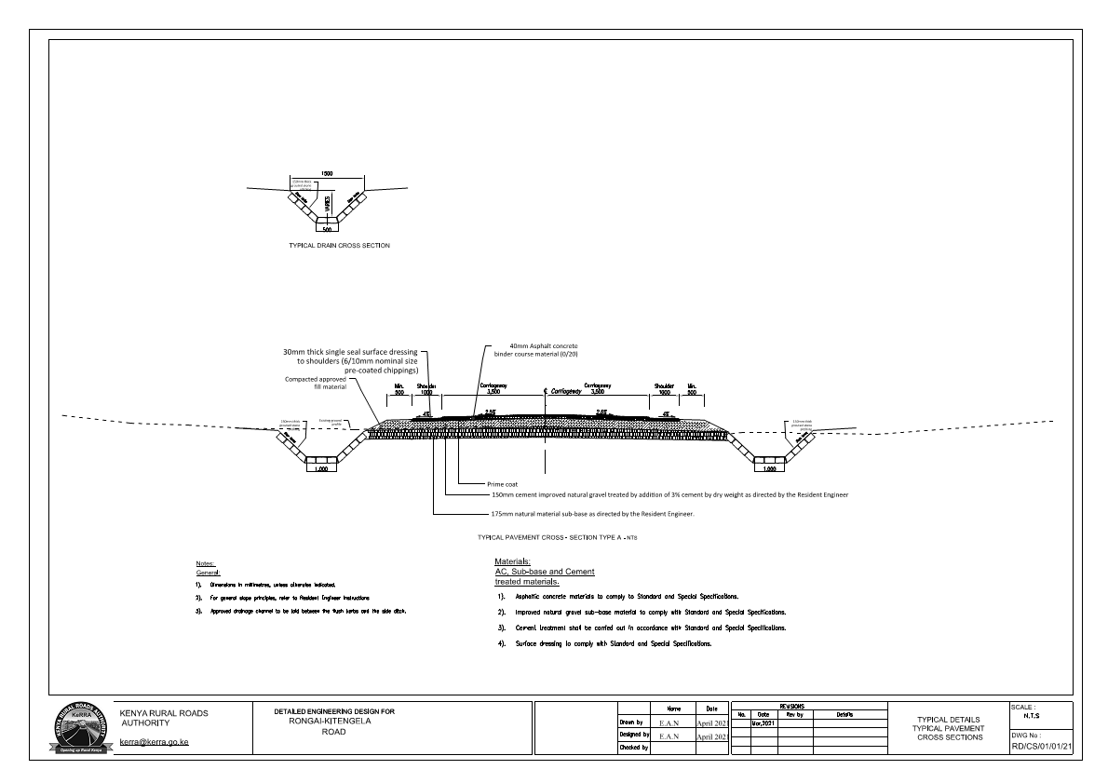

Figure 1: Road design of proposed project

# BASELINE SURVEY

## Introduction

The road survey began at the proposed Rusinga schools campus site, at Latitude-Longitude coordinates (-1.3986755, 36.79066426) and ended at the quarry, Lat-Lon coordinates (-1.40834375, 36.82985959). There were a few important features noticed along the road route, such as Tuala centre and SGR overpass, (-1.40220242, 36.80488978) and (-1.40132149, 36.81747036) respectively. The road survey began at approximately 12 noon and ended at 1:45pm. Though the entire road is a stretch of 26km from Ongata Rongai to Kitengela, due to constraints of time only 6.4km was surveyed.

Table 1: Surveyed areas along the road route

| Point | Latitude | Longitude | Accuracy(m) | Altitude(m) | Description |
| --- | --- | --- | --- | --- | --- |
| 1 | -1.39068412 | 36.76967061 | 4 | 1709 | Junction at Magadi road |
| 2 | -1.3986755 | 36.79066426 | 9 | 1682 | Start of murram road |
| 3 | -1.3974481 | 36.79812947 | 3 | 1660 | Bend before reaching the bridge crossing river Kandisi |
| 4 | -1.39734767 | 36.79817471 | 5 | 1655 | a few metres to the bridge |
| 5 | -1.39969483 | 36.79962135 | 3 | 1674 | A group of zebras were sighted grazing in an open field |
| 6 | -1.40220242 | 36.80488978 | 3 | 1681 | Twala centre |
| 7 | -1.40132149 | 36.81747036 | 3 | 1649 | Overpass of SGR |
| 8 | -1.40157005 | 36.8218044 | 4 | 1632 | Eucalyptus plantation next to SGR barrier |
| 9 | -1.40291262 | 36.82966621 | 4 | 1623 | Location of seasonal river |
| 10 | -1.40457771 | 36.8349445 | 4 | 1626 | A few metres past the bend adjacent to Cockpit hotel |
| 11 | -1.40756392 | 36.82987579 | 9 | 1656 | Field after bend toward quarry |
| 12 | -1.40834375 | 36.82985959 | 3 | 1655 | Quarry |

### Baseline data collection methods

Random sampling method was used to conduct both biodiversity and physical environment investigations. Data collection methods used were notetaking and photography.

## Physical Environment

### Topography

The topography of the area is generally undulating with gentle slopes. The highest point along the road route was at the proposed Rusinga Schools Campus (1682m). The area with the lowest altitude was at a seasonal river near Cockpit hotel (1623m). The topography of the road route declines slowly from West to East. Areas with flat topography to gentle slopes are from the site of the proposed Rusinga schools campus and at Twala centre. The area with the steepest gradient in a descending trend, from West to East is between Twala Centre and the seasonal river located near Cockpit hotel. The topography of the land between these two sites has a difference of 50m of altitude, from 1680m at Twala centre to 1630 at Cockpit hotel and close to the quarry. From the site of Cockpit hotel, the land gently rises to 1650m at the abandoned quarry site. The entire area has a gentle slope gradient of less than 14 degrees inclination.

### Geology

The main rock types at the abandoned quarry site were phonolites and phonolite tuffs. Such rocks are of volcanic origin, dark-colored and easily breakable. These phonolites are part of the local geological volcanic rocks known as Kapiti phonolites that cover a large section of Nairobi metropolitan, extending from Ngong Hills to Limuru. The area along the road route had some exposed rock outcrops of metamorphic origin, which were mentioned by Saggerson (1991) as one of the characteristic features of the Kapiti phonolites West of Nairobi National Park. These Kapiti phonolites are believed to have originated from lava flows during the Miocene time period. These lava flows most likely originated from fissures since no exposed central volcano can be located in the area. The characteristic reddish brown and sandy soils located along the Ongata Rongai road, Tuala centre and at the quarries suggest that the proposed road overlies the Basement system, which is a geologic outcrop running along the lower rift valley. Other rocks existent along various sections of the road are Mbagathi trachytes and Upper Athi tuffs. The former are known to appear near rivers, while soils originating from the latter are characterized by a yellow colour (Matheson, 1966).

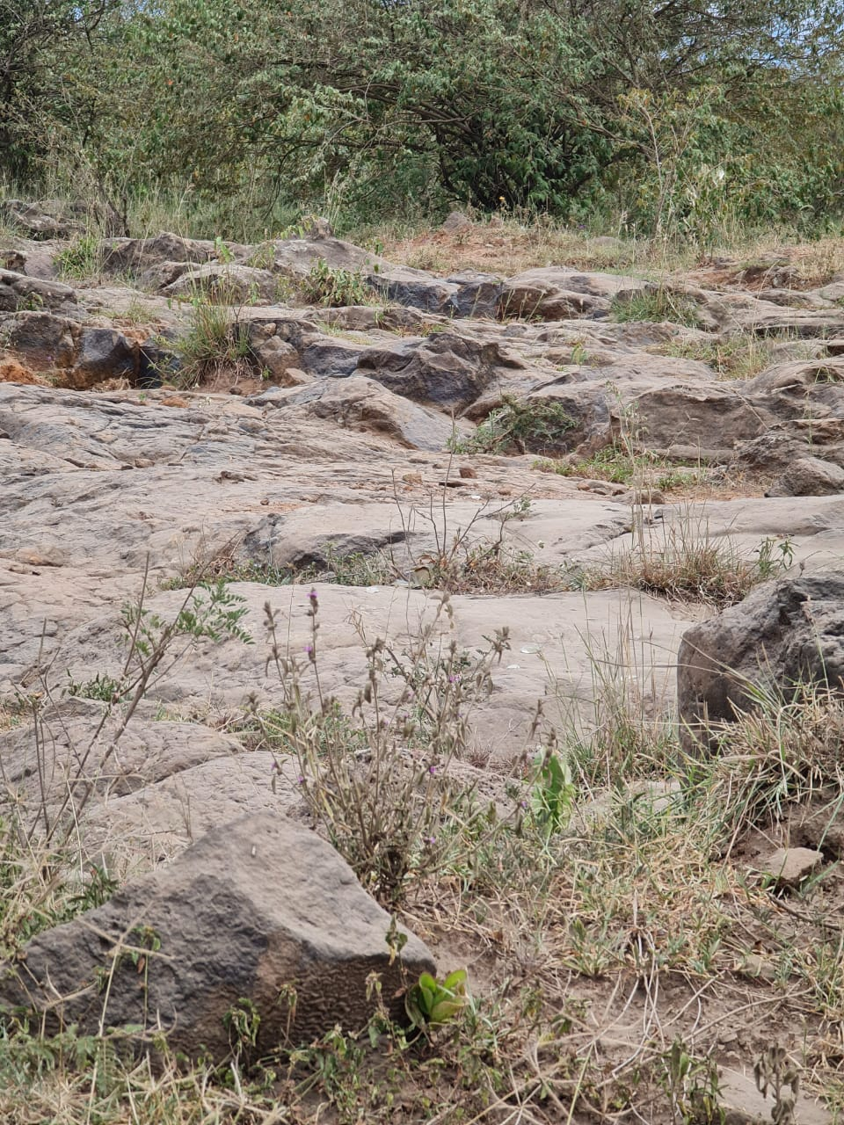

Figure 2: Exposed outcrops of metamorphic rock

### Climate

The climate of Kajiado is characterized as cool and dry. Temperatures variation ranges from 15°C to 28°C with the lowest temperatures experienced at the top of Ngong hills and the highest at Lake Magadi. Amboseli receives the lowest mean annual rainfall amounts (300mm) while Ngong Hills and the slopes Mt Kilimanjaro experience the highest mean annual rainfall amounts (1250mm). The temperature range at which the surveyed road route passes through is between these two extremes. The temperature of the area increases inversely proportional to precipitation amounts as one moves away from Ongata Rongai. The change in climate is exemplified by the decrease in the density of trees away from Ongata Rongai, where the road is partly covered by Oloolua forest, but scrub vegetation gradually increases from Tuala centre and onto Kitengela. Temperature differences between the two key points of the route (Ongata Rongai and Kitengela) are marginal, with the former having a mean daily temperature of 18°C while the latter having a mean daily temperature of 19°C. Precipitation differences are however significant with Kitengela, the final destination of the road route having higher annual precipitation of 744mm compared to Ongata Rongai’s 590mm.

### Hydrology

Two rivers were spotted along the road route from Ongata Rongai to the quarry sites. These were River Kandisi, sited at the first bridge along the route, and an unnamed seasonal river near Cockpit hotel. The rivers flow in a South East to North West direction. River Kandisi, which originates from Ngong forest, is a tributary of Mbagathi river. Both the river Kandisi and the unnamed river have their peak flow during the long rain seasons. Their water volume, however, diminishes during extended dry periods due to reduce overland flow and groundwater replenishment.

At the quarry site, surface run-off had accumulated to form a pool of stagnant water at the quarry. All these three surface water bodies along the proposed road route had a characteristic yellow colour showing that they had high sediment concentrations. The volume of the stagnant water has remained the same despite the high potential evapotranspiration of the area most likely because the base of the quarry is hard bedrock. Hard bedrock is impermeable, thus groundwater seepage does not take place which could otherwise have drained the water to the ground below. Apart from these three water bodies, there are no other surface water bodies in the area.

### Soils

The soils along the proposed road route are brown to yellow in colour, are loose and granular. Deposits of fine sediments were noticed along the banks of river Kandisi. The soils in Oloolua forests and at the quarry site are classified as a mixture of vertisols, and sandy soil. The vertisols, commonly known as black cotton soil, according to literature is prevalent to Ongata Rongai, Ngong and Kitengela environs. Regosols, a soil type mainly composed of sand and silica, are more dominant in areas further away from Ongata Rongai. Other soils mentioned to be near the area are Nitisols (NEMA, 2009). Overall, soils of Kajiado county become less fertile as one crosses from the sub-humid to the semi-arid landscapes of Kitengela, Isinya and Magadi. Therefore, as a rough estimate, the most fertile soils are near Ongata Rongai town, and soil fertility decreases along the road route until the quarry site where Vertisols are more dominant (NEMA, 2009).

Figure 3: Profile of the entire road route surveyed

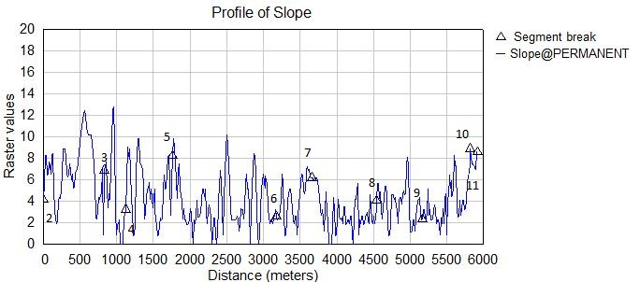

Figure 4: Slope profile of the road route

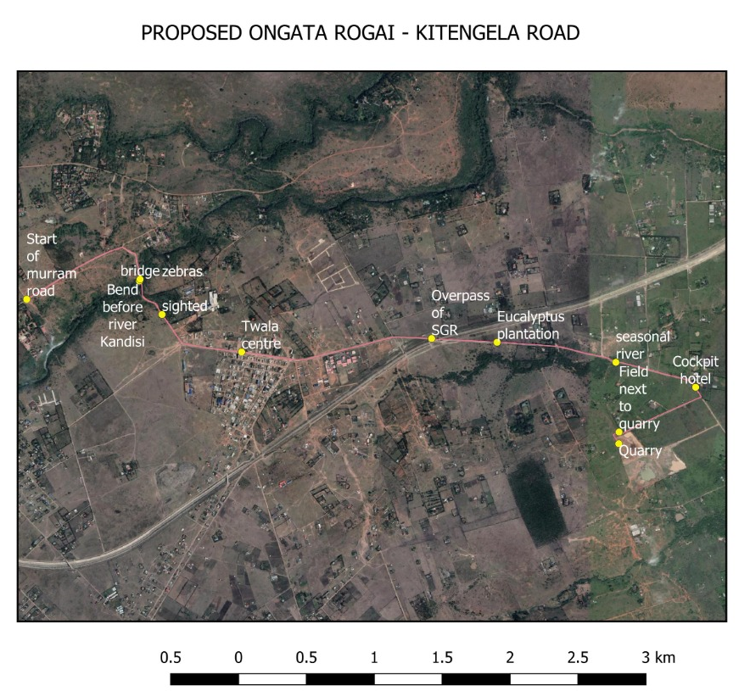

## Biological Environment

### Vegetation

The main vegetation type in the area is determined by the soil type. However, the main vegetation types in the area comprise wooded and open grassland. The woody species predominant in the area is the *Acacia tortilis* while the grasses include *Pennisetum mezianum* which is good grazing grass when young but becomes stemmy and unpalatable as it grows.

### Animals

Traditionally, the area through which the proposed road traverses has various types of domesticated animals. These include cows, sheep, goats, donkeys, chicken and dogs. Due to its close proximity to the Nairobi National Park, there are incidences where some wild animals are spotted in the area. During the survey along the road route, Zebras were spotted.

## Socio-economic Environment

### Population

Kitengela and Rongai have a combined population of 327,005 (168,218 male and 158,787 female). Both Kitengela and Rongai hold most of the urban population than any other town in the county with 41 percent of the total. The male urban population (51.4 percent) is more compared to Female urban population (48.6 percent) (KNBS, 2019).

### Land use

Land is mainly used for livestock rearing and crop growing. There is a significant change in land use in the area where industrial and commercial use is gaining momentum. There is growing level of land speculation in the areas leading to excessive subdivision of land to small and sometimes uneconomical plots.

### Livelihood

Kitengela and Rongai area is a semi-urban area with a range of households which on average largely depend on livestock related earnings (including meat and milk). However, some members of the community depend more on petty trading and other informal sector activities. Such trading and commercial activities are conducted in Kitengela and Rongai towns where you find butcheries, hardware shops, clothes shops and the markets where groceries, fruits, second-hand clothes, kitchen utensils, shoes are sold. Other personnel are engaged in the petrol stations, eateries, shopping malls and banks in the town to earn their livelihoods.

### Real Estate

The overflow of population in Nairobi City has pushed people out in search of better and affordable housing. This has resulted in a property boom in the area. The area’s close proximity to Nairobi makes it even more attractive.

### Infrastructure & amenities

The project site is growing constantly with rapid developments of large estates, industries, intensive farming and learning institutions. The Standard Gauge Railway (SGR) passes through the project site. Kitengela and Rongai towns and their environs have business premises developing rapidly. These include shopping malls, residential estates, universities such as the African Nazarene University, banks, among others. However, the area lacks most of the required facilities e.g. solid waste management, water and sewage systems, proper drainage, roads and vehicles parking, and transportation. On a positive note, the area enjoys very good coverage of mobile phone service.

Figure 5: Land cover along the proposed route

# POLICY, LEGAL AND INSTITUTIONAL FRAMEWORK

## Introduction

The environmental sector in Kenya is guided by a series of national policies, legal and institutional framework to ensure that environmental management is well provided for and no loopholes exist that may adversely impact the environment. For this reason, the road industry relies on various policies and laws and is guided by an effective institutional framework to ensure that there is proper environmental regulation that serves to protect, conserve and manage the environment as well as shield it from environmental exploitation and degradation. Furthermore, the road development is expected to spur socio-economic development, improve security and provide an effective and efficient means of transportation.

Under the administrative framework, the National Environment Management Authority (NEMA) is responsible for ensuring that environmental impact assessments (EIAs) are carried out for new projects and environmental audits on existing facilities as per the requirements of the Environmental Management and Coordination Act (EMCA) 1999. Projects subject to this requirement are specified in the Second Schedule of the EMCA, 1999.

Additionally, through funding from financial institutions, policies may be developed to ensure that the funds are well utilized for the intended purpose and that the environment is well protected, conserved and managed and the society living in the area are not adversely impacted by the development projects.

Environmental and Social Impact Assessments (ESIAs) are carried out in order to identify potential positive and negative impacts associated with a proposed project. The aim is to amplify the positive impacts and develop mitigation measures for the negative ones. The ESIA also ensures that baseline environmental and socio-economic data for the proposed project is collected and used in the design of projects financed by the bank. Additionally, the data collected is used for monitoring and evaluating project impacts during the project cycle. It is a requirement by NEMA that a clear management plan and action plan that describe and prioritize the actions required in implementing mitigation measures are put in place.

## National Policy Framework

The Republic of Kenya has a policy, legal and administrative framework for environmental management. The broad objectives of the national environmental policy in Kenya are:-

* To ensure optimal use of natural resources while improving environmental quality.
* To conserve natural resources such that the resources meet the needs of the present without jeopardizing future generations in enjoying the same.
* To develop awareness that inculcates environmental stewardship among the citizenship of the country.
* To integrate environmental conservation and socio-economic aspects in the development process.
* To ensure that national environmental goals contribute to international obligations on environmental management and social integrity.

To achieve the above policy objectives, it is a policy directive that appropriate reviews and evaluations of all forms of developmental project plans and operations are carried out to ensure compliance with the environmental policy and legal frameworks.

The following section provides details on the relevant policies in the country.

### Kenya Vision 2030

Kenya Vision 2030 is a comprehensive national development plan for period 2008 to 2030. The plan was developed following successful implementation of the Economic Recovery Strategy for Wealth and Employment Creation which ensured the country’s economy was back on the path for realization of rapid economic growth since 2002. The county’s GDP growth rose from 0.6% to 7% in 2007, but declined to 1.7% and 1.8% in 2008 and 2009, respectively.

The objective of the Vision 2030 is to transform Kenya into a middle income country with a consistent annual economic growth of 10 % by the year 2030. The 2030 goal for urban areas is to achieve “a well-housed population living in an environmentally-secure urban environment.” This goal is expected to be achieved by developing basic infrastructure services such as roads, street lights, water and sanitation facilities, storm water drains, footpaths, and others while ensuring that the country has a clean, secure and sustainable environment by 2030 through reduction of pollution and improvement of waste management.

The plan also requires that the current land use practices in the country be reviewed due to the fact that they are incongruent with the ecological zones. The proposed road project will contribute to the realization of the goals of Vision 2030 through improvement of a reliable and efficient road infrastructure facility, provision of employment opportunities, and provision of faster and efficient mode of transport, among others.

### National Environmental Action Plan (NEAP) Guidelines of 2016

The National Environment Action Plan (NEAP) Preparation Guidelines for Kenya was formulated in 2016 through a consultative process involving various stakeholders. The action plan was aimed at integrating environmental considerations into the country’s socio-economic development.

The integration process was to be realised through development of a comprehensive framework that ensures linkage of environmental management of natural resources to decision-making processes. The NEAP also established the process of identifying environmental problems and issues, awareness raising, building national consensus, defining policies, legislation and institutional needs, and planning environmental projects.

### The Poverty Reduction Strategy Paper (PRSP) of 2000

The Poverty Reduction Strategy Paper (PRSP) for Kenya had the broad objective of reducing poverty and promoting economic growth. This policy articulated Kenya’s commitment and approach to tackling endemic poverty through involvement of the poor communities in both rural and urban areas in various socio-economic development activities.

The proposed project, during and after implementation will offer various employment opportunities to Kenyans and will therefore contribute directly towards the realisation of the broad national goal of reducing poverty in the country. In addition the project would stimulate economic development by creating an enabling environment for other key sectors of the economy to thrive.

### Sessional Paper No.10 of 2014 on The National Environment Policy

The Kenya’s policy paper on the The National Environment Policy was formulated in 2014. The policy defined approaches that will be pursued by the Government in mainstreaming environment into development. The policy harmonized environmental and developmental objectives with the broad goal of achieving sustainable development.

The policy paper also provided guidelines and strategies for government action regarding environment and development. With regard to wildlife, the policy reemphasized government’s commitment towards involving local communities and other stakeholders in wildlife conservation and management, as well as developing mechanisms that allow them to benefit from the natural resources occurring in their areas.

The policy also advocated for the establishment of zones that allow for the multiple use and management of wildlife. This policy is relevant to the proposed development project in view of the potential impacts on the environment and involvement of the public in project planning.

### The National Biodiversity Strategy of 2019

The National Biodiversity Strategy and Action Plan (NBSAP) was formulated in order to enable Kenya address national and international commitments defined in Article 6 of the Convention on Biological Diversity (CBD).

The strategy is a national framework of action for ensuring that the present rate of biodiversity loss is reversed and present levels of biological resources are maintained at sustainable levels for posterity.

The general objectives of the strategy are to conserve Kenya’s biodiversity; to sustainably use its components; to fairly and equitably share the benefits arising from the utilization of biological resources among the stakeholders; and to enhance technical and scientific cooperation nationally and internationally, including the exchange of information in support of biological conservation. The proposed road project will need to comply with the requirements of this strategy since the project may lead to loss of biodiversity in some sections along the proposed route.

### The Land Policy (2017)

The Land Policy in Kenya is guided by the environmental management principles which are aimed at restoring the environmental integrity through introduction of incentives and encouragement of use of technology and scientific methods for soil conservation, among others.

The policy further requires fragile ecosystems to be managed and protected by developing a comprehensive land use policy bearing in mind the needs of the surrounding communities.

The policy also requires zoning of catchment areas to protect them from degradation and establishment of participatory mechanisms for sustainable management of fragile ecosystems.

The policy also called for development of procedures for co-management and rehabilitation of forest resources while recognizing traditional management systems and sharing of benefits with contiguous communities and individuals. Lastly, all national parks, game reserves, islands, front row beaches and all areas hosting fragile biodiversity are declared as fragile ecosystems under the policy.

The policy recognizes that sustainable management of land based natural resources depends largely on the governance system that defines the relationships between people, and between people and resources.

To achieve an integrated approach to management of land-based natural resources, all policies, regulations and laws dealing with these resources need to be harmonized with the framework established by the Environmental Management and Coordination Act (EMCA) 1999.

The policy further calls for the protection of watersheds, lakes, drainage basins and wetlands. The policy prohibits settlement and agricultural activities in water catchment areas and calls for identification, delineation and gazettement of all water courses and wetlands.

### Wildlife Policy of 2020

The wildlife policy is aimed at promoting protection and conservation of wildlife in Kenya, both in protected and non-protected areas. The policy is implemented by the Kenya Wildlife Service (KWS).

The proposed road project will need to be consistent with this policy. Where wild animals will be disturbed during the construction and operation of the road, appropriate mitigation measures must be implemented to minimize disturbance to wildlife.

### Wetlands Policy of 2013

The wetlands policy is intended to promote protection of wetlands in Kenya. The policy sets out strategic measures for the protection of existing wetlands in Kenya. The proposed road has potential of impacting several wetlands such as River Kandisi. It would be important to undertake appropriate mitigation measures in order to minimize or avoid degradation of wetlands.

### Physical Planning Policy

The current policy governs the development and approval all building plans as provided for in the **Physical Planning Act (Cap 286)**. The proposed project will be subjected to the provisions of this policy and legislation.

### Public Health Policy of 2014

The public health policy calls upon the project proponents to ensure that buildings are adequately provided with utilities so that they are fit for human habitation. The workers camps must be provided with all amenities/utilities that are essential for safeguarding public health for all people using the facilities.

### HIV/AIDS Policy of 2009

The policy identifies HIV/AIDS as a global crisis that constitutes one of the most formidable challenges to development and social progress. The Pandemic heavily affects the Kenyan economy through loss of skilled and experienced manpower due to deaths, loss of man hours due to prolonged illnesses, absenteeism, reduced performance, increased stress, stigma, discrimination and loss of institutional memories, among others. Due to the large of number of workers who will be involved in the project and the associated social issues with projects of such as scale, HIV/AIDS has been considered as one of the proposed impacts but adequate mitigation measures have also been proposed to that effect.

### Gender Policy of 2011

The purpose of the Gender Policy is to institutionalize The Kenya National Policy on Gender and Development (NPGD), within Gender, Children and Social Development. It articulates the policy approach of gender mainstreaming and empowerment of women at the ministry level. The policy seeks to have a society where women, men, children and persons with disabilities enjoy equal rights, opportunities and a high quality of life. This report has in depth addressed matters to do with gender and development and in the concession period the entire project period the project shall be governed under this principle.

### The Kenya National Climate Change Response Strategy of 2010

This strategy provides measures that the Government of Kenya is taking to address issues related to the impact of climate change on various sectors of the economy. The proposed road will need to take on board the effects of changing climate in the country, and apply applied climate change mitigation measures. This is important because climate change will in future affect the operation of the road.

## National Environmental Legal Framework

The Republic of Kenya has numerous statutes that guides environmental management and conservation in the country. Most of these statutes are sector specific and cover a wide range of issues including public health, soil conservation, protected areas conservation, endangered species, public participation, water rights, water quality, air quality, excessive noise control, vibration control, land use, among others. The relevant legislations are described in the following sections.

### The Constitution of Kenya of 2010

The Constitution of Kenya has taken on board various issues that are related to environmental management.

Article 42 of the Bill of Rights contained in the Constitution provides that ‘every Kenyan has the right to a clean and healthy environment, which includes the right to have the environment protected for the benefit of present and future generations through legislative and other measures.

Chapter 5 of the Constitution is dedicated to land and the environment. The constitution requires that land be used and managed in a manner that is equitable, efficient, productive and sustainable.

Part 2 of Chapter 5 of the constitution is dedicated to Environment and Natural Resources. Article 69 in Part 2 provides that the state shall provide encourages efforts towards sustainable of natural resources, increasing of the national forest cover public participation in the management, protection and conservation of the environment, protection of genetic resources and biodiversity, environmental impact assessment, environmental audit and monitoring of the environment, etc.

The proposed project should ensure compliance with the constitutional requirements in as far as equitable sharing of the resources between various stakeholders is concerned on matters of sustainability of livelihoods and biological resources public participation Resettlement Action Plan among others.

The Kenyan constitution also gives prominence to public participation; as a general national value in environmental protection. Article 69(1) states that the State shall encourage public participation in the management, protection, and conservation of the environment.

### Environmental Management and Coordination Act No 8 of 1999

The Section Part VI of EMCA 1999 Part II states that every person is entitled to a clean and healthy environment and has the duty to safeguard the same. In order to achieve this goal, the projects listed under the Schedule No. 2 of EMCA must be subjected to Environmental Impact Assessment (EIA). The aim of EIA is to reduce negative environmental outcomes of the listed projects by implementing mitigation measures. The proposed project falls within the Second schedule and must therefore comply with EMCA requirements in as far as EIA is required. There are also several regulations that have been formulated within the framework of EMCA 1999 that are applicable to the proposed project. These are listed in the following sections.

### Environmental Management and Co-ordination (Environmental Impact Assessment and Audit) Regulations, 2003

The Environmental (Impact Assessment and Audit) Regulations provides guidelines for conducting EIA studies. The regulations provide details on the parameters to be evaluated when undertaking an EIA study. It also provides guidelines on the conduct of environmental audits and development of project monitoring plans. The proposed project must comply with the requirements of the regulations that also include conducting continuous monitoring and annual audits on the proposed project.

### Environmental Management and Co-ordination (Water Quality) Regulations, 2006

The EMCA (Water Quality) Regulations, 2006 provide guidelines on the use and management of water sources in order to safeguard quality of water for domestic use and irrigation, among others. The proposed project will need to comply with the requirements of this regulation in order to ensure water sources along the route are protected from pollution and over abstraction.

The project will also need to comply with the regulations that prohibit undertaking of development within a minimum of 6m from the highest ever recorded flood level of a river system. Section 4(2), 6 and Section 24 of the regulation prohibits pollution of water bodies and requires that all substances discharged into the water bodies should meet the standards set under the Third Schedule of the regulation.

Everyone is required to refrain from any actions, which directly or indirectly cause water pollution, whether or not the water resource was polluted before the enactment of the Environmental Management and Coordination Act (EMCA) Gazetted in 1999.

It is an offence to contravene the provisions of these regulations with a fine not exceeding five hundred thousand shillings. In response to the above, the project design team should be advised on the requirements of this regulation and appropriately incorporate the regulations in the project design document.

### Environmental Management and Co-ordination (Fossil Fuel Emission Control) Regulations, 2006

The EMCA (Fossil Fuel Emission Control) Regulations, 2006 aims at eliminating or reducing emissions emitted from internal combustion engines to acceptable levels. The regulation provides guidelines on use of clean fuels, use of catalysts and inspection procedures for engines and generators. This regulation is applicable to the proposed project since there would be use of vehicles, machineries and equipment that depend on fossil fuel as their source of energy. The requirements of the regulation must be implemented in order to eliminate or reduce air quality degradation. Sections of the regulation citing the standards of recommended emission levels will be given to the contractor and or pinned at strategic points in the contractor’s field offices.

### Environmental Management and Co-ordination (Conservation of Biological Diversity and Resources, Access to Genetic Resources and Benefit Sharing) Regulations, 2006

The EMCA (Conservation of Biological Diversity and Resources, Access to Genetic Resources and Benefit Sharing) Regulations, 2006 provides that no person shall engage in any activity that may have an adverse impact on any ecosystem; may lead to the introduction of any exotic species or to unsustainable use of natural resources, without an Environmental Impact Assessment License issued by the Authority under the Act. The regulation requires NEMA in consultation with the relevant lead agencies, to impose bans, restrictions or similar measures on the access and use of any threatened species in order to ensure its regeneration and maximum sustainable yield. The proposed road traverses areas with diverse ecosystems which will need to be protected as per the requirements of this regulation.

### Environmental Management and Co-ordination (Waste Management Regulations, 2006)

The Waste Management Regulations are basically aimed at streamlining the handling, transportation and disposal of various types of wastes. The broad goal of the regulations is to protect human health and the environment. The regulations place emphasis on waste minimization, cleaner production and segregation of waste at source.

The regulations have also classified various types of waste and recommended appropriate disposal methods for each waste type. Under the regulations, NEMA is supposed to licenses transporters, incinerators, landfills, composers, recyclers and transfer stations. Facilities to be licensed include local authorities, transporters and handlers of various types of waste. The licensing employs a risk-based approach by concentrating on facilities considered to pose a high risk to the environment.

The regulations also provide an opportunity for investment in various aspects of waste management. During the construction of the proposed road, proper disposal of wastes will need to be observed by the contractor at the workers camps and the road works. This will ensure good hygiene and healthy working environment for workers.

### Environmental Management and Co-ordination (Controlled Substances) Regulations, 2007

The EMCA (Controlled Substances) Regulation is aimed at controlling the production, consumption and, exports and imports of controlled substances. Controlled substances are grouped into three lists as indicated below:

* Group 1 list consists of halogenated flouro-chemicals with ozone depleting substances.
* Group 2 list consist of hydrobromoflourocarbons with ozone depleting substances.
* Group 3 list consist of bromochloromethane with ozone depleting substances.

Products containing controlled substances include air conditioners, air coolers, refrigerants, portable fire extinguishers, heat pump equipment, dehumidifiers, insulation boards, panels and pipe covers, pre-polymers, etc.

The project contractors will need to ensure that the requirements of this regulation are observed in order to ensure that equipment, machinery, vehicles and chemicals containing such components are not imported into the country for use in the proposed project.

### Environmental Management and Co-ordination (Wetlands, River Banks, Lake Shores and Sea Shore Management) Regulations, 2009

The Environmental Management and Co-ordination (Wetlands, River Banks, Lake Shores and Sea Shore Management) Regulations, 2009 applies to all wetlands in Kenya whether occurring in private or public land. The objectives of the regulations is to provide for the conservation and sustainable use of wetlands and their resources in Kenya and promote the integration of sustainable use of resources in wetlands into the local and national management of natural resources for socio-economic development.

The act also aims at ensuring the conservation of water catchments and the control of floods and the sustainable use of wetlands for ecological and aesthetic purposes for the common good of all citizens.

The act further makes provision for the protection of wetlands as habitats for species of fauna and flora. It also provides a framework for public participation in the management of wetlands.

The Act requires wetland resources to be utilized in a sustainable manner compatible with the continued presence of wetlands and their hydrological, ecological, social and economic functions and services.

The Act further requires special measures to be undertaken to preserve and maintain knowledge innovations and practices of indigenous and local communities embodying traditional lifestyles relevant for the conservation and sustainable use of biological diversity in wetlands.

Additionally, the regulation calls for sustainable use of wetlands through integration into the national and local land use plans to ensure sustainable use of wetlands in the country. The road crosses the River Kandisi, which is a valuable wetland and water resource along the route. The contractor will need to employ measures for the preservation and conservation of the wetlands and river system.

### Environmental Management and Co-ordination (Noise and Excessive Vibration Pollution Control) Regulations, 2009

The Noise and Excessive Vibration Pollution Control Regulations, 2009 prohibits excessive noise and vibration. It states that no person shall make or cause to be made any loud, unreasonable, unnecessary or unusual noise which annoys disturbs, injures or endangers the comfort, repose, health or safety of others and the environment. The contactor of the road will have to ensure that no excessive noise and vibrations are made during the construction of the road. This is important since the construction of the new road will involve use of heavy earthmoving equipment and trucks which can generate excessive noise and vibrations.

Motor vehicles used during the construction of the proposed road should also adhere to the regulations which prohibit excessive noise. The provision of the act on motor vehicle states that no person shall operate a motor vehicle which produces any loud and unusual sound exceeding 84 dB(A) when accelerating.

The Act provides that no person shall at any time sound the horn or other warning device of a vehicle except when necessary to prevent an accident or an incident. Any person carrying out construction, demolition, mining or quarrying work should ensure that the vibration levels do not exceed 0.5 centimeters per second beyond any source property boundary or 30metres from any moving source.

### The Wildlife (Conservation and Management) Act 2013

The Wildlife and Conservation Act deals with the conservation and management of wildlife in Kenya. The Act provides that wildlife should be conserved so as to yield optimum returns in terms of cultural, aesthetic, scientific and economic benefits.

The Act requires that full account be taken of the inter-relationship between wildlife conservation and land use. The Act controls activities within the national parks, which may lead to the disturbance of wild animals.

Unauthorized entry, residence, burning, damage to objects of scientific interest, introduction of plants and animals and damage to structure are prohibited under this law. The proposed road traverses a wildlife corridor. The road construction will need to create a barrier for the free passage of wildlife. Passage provisions will need to be integrated into the design of the road. The contractor will also need to provide free wildlife passages so that the road project does not affect wildlife negatively.

### The Water Act 2016

The Act stipulates that a permit shall be required in all cases of proposed diversion, abstraction, obstruction, storage or use of water, with minor exceptions relating to use for domestic purposes.

Under the Water Act (General) Rules, it is stated that any rights acquired under the permit are subject to the Public Health Act and the Malaria Prevention Act, in addition to the Water Act itself.

The Public Health Act has wide-ranging provisions on pollutant discharges, which are set out below.

Furthermore, The Water Act (General) Rules make provision for discharges in a number of respects, as follows: Effluent shall not be returned to any body of water unless it has been purified.

Further, it must not contain poisonous or injurious matter or excess silt, gravel or boulders.

It is an offence to allow effluent discharges, either domestic or industrial, if this would harm fish. Plans for rendering such effluent innocuous shall be submitted to and approved by the enforcing authority.

Additionally the applicant for a water permit is required to outline the methods to be used for treating effluent before discharge. The permit would only be issued subject to satisfactory provision being made for the treatment of effluent.

The Water Act, apart from the Rules, makes only limited provision for controlling water pollution. The provision is limited to the pollution of drinking water for instance the Act provides that the water undertaker may make regulations to control polluting activities, which may threaten its source of water. It may itself construct the necessary works for intercepting, treating or disposing of foul water. Furthermore, the Act makes it an offence to pollute such waters. Similarly, it is also an offence to throw or convey polluting matter into a body of water.

### The Agriculture and Food Authority Act of 2013

Agriculture and Food Authority Act, 2013 (No. 13 of 2013) provides for the establishment of the Agriculture and Food Authority, the administration of matters of agriculture and the preservation, utilization and development of agricultural land and related matters.

"Agriculture" in this Act means cultivation of land and the use of land and water for any purpose of husbandry, aquaculture and food production and includes cultivation of crops and horticultural practice, breeding of aquatic animals and plants, the use of land, fish harvesting and the use of land for agroforestry.

The Act requires the Authority in consultation with the county governments to promote best agricultural practices. The Cabinet Secretary is required under the Act with the advice of the Authority, and in consultation with the National Land Commission, to provide general guidelines applicable in respect of any category of agricultural land. These land development guidelines are to be implemented by the county governments. In a like manner, the Cabinet Secretary is given powers to make general rules for the preservation, utilization and development of agricultural land and aquatic resources and prescribe national guidelines for soil conservation.

Each county government is required to keep a register of land development orders and land preservation orders, which they may issue under this Act. The Act also provides for participation by farmers. This is an important aspect in the construction of the road as the County of Kajiado’s main economic activity is agriculture and the impacts brought about by the road have a positive aspect on the growth of the town’s economy.

### Energy Act, No.1 of 2019

This is an Act of Parliament to amend and consolidate the law relating to energy, to provide for the establishment, powers and functions of the Energy Regulatory Commission and the Rural Electrification Authority, and for connected purposes.

The provisions of this Act apply to every person or body of persons importing, exporting, generating, transmitting, distributing, supplying or using electrical energy; importing, exporting, transporting, refining, storing and selling petroleum or petroleum products; producing, transporting, distributing and supplying of any other form of energy, and to all works or apparatus for any or all of these purposes.

This Act is relevant to the proposed road project due to the need to relocate some of the petrol stations situated along the route. The Act establishes a Commission known as the Energy Regulatory Commission. The commission’s role, among others identified in the Act, is to regulate:

1. Importation, exportation, generation, transmission, distribution, supply and use of electrical energy,
2. Importation, exportation, transportation, refining, storage and sale of petroleum and petroleum products;
3. Production, distribution, supply and use of renewable and other forms of energy.

### The Land Registration Act, 2012

This is an Act of Parliament that revises, consolidates and rationalizes the registration of titles to land, to give effect to the principles and objects of devolved government in land registration, and for connected purposes. The act requires that proper marking and maintenance of boundaries. An interested person who has made an application to the Registrar for his/her boundaries to be ascertained, the Registrar shall give notice to the owners and occupiers of the land adjoining the boundaries in question of the intention to ascertain and fix the boundaries. With regard to the maintenance of boundaries, the Act requires every proprietor of land to maintain in good order the fences, hedges, stones, pillars, beacons, walls and other features that demarcate the boundaries, pursuant to the requirements of any written law.

### The National Land Commission Act, 2012 (No. 5 of 2012)

The National Land Commission of Kenya is an independent government commission whose establishment was provided for by the Constitution of Kenya to, amongst other duties, manage public land on behalf of the national and county governments, initiate investigations into present or historical land injustices, recommend appropriate redress, monitor and have oversight responsibilities over land use planning throughout the country.

It was officially established under The National Land Commission Act, 2012. The mandate of the National Land Commission is drawn from the National Land Policy of 2009, Constitution of Kenya 2010, National Land Commission Act, 2012, the Land Act 2012 and the Land Registration Act of 2012. Under the National Land Commission Act, the Commission shall among others duties monitor the registration of all rights and interests in land and ensure that public land and land under the management of designated state agencies are sustainably managed for their intended purpose and for future generations.

Additionally, the commission is required to manage and administer all unregistered trust land and unregistered community land on behalf of the county government and develop and encourage alternative dispute resolution mechanisms in land dispute handling and management. The Commission is also required in consultation and cooperation with the national and county governments, to establish county land management boards for the purposes of managing public land.

### Community Land Act 2016

The Community Land Act, No. 27 of 2016 (the Act) came into force on 21 September 2016. The Act aims at:

* Giving effect to Article 63 of the Constitution of Kenya, 2010 (the Constitution) which provides for a classification of land known as community land. To this end, the Constitution provides that community land shall vest in and be held by communities.
* Providing for;
* The recognition, protection and registration of community land rights.
* The management and administration of community land.
* The role of county governments in relation to unregistered community land and related matters.

The Act repeals the Land (Group Representatives) Act (Chapter 287 of the Laws of Kenya) and the Trust Lands Act (Chapter 288 of the Laws of Kenya). This project shall uphold the requirement of all the relevant land legislations, involving key administrative stakeholders and the affected parties (i.e. the community) facilitating in coexistence with the surrounding community.

### The Environment and Land Court Act, 2011

This is an Act of Parliament to give effect to Article 162(2) (b) of the Constitution to establish a superior court to hear and determine disputes relating to the environment and the use and occupation of land.

The Environment and Land Court (ELC) is one of the Courts contemplated by article 162(2). It is a Superior Court and has the same status as the High Court. The court is established under section 4 of the Environment and Land Court Act No. 19 of 2011.

The ELC has jurisdiction to hear any other dispute relating to environment and land. The jurisdiction of the court is provided under section 13 of the Act.

The Court has original and appellate jurisdiction to hear and determine all disputes in accordance with Article 162(2) (b) of the Constitution and with the provisions of the Act or any other written law relating to environment and land.

The court has powers to deal with disputes relating to land administration and management. The court is also empowered to hear cases relating to public, private and community land and contracts or other instruments granting any enforceable interests in land.

The court also exercises appellate jurisdiction over the decisions of subordinate courts or local tribunals in respect of matters falling within the jurisdiction of the Court.

The court further exercises supervisory jurisdiction over the subordinate courts, local tribunals, persons or authorities in accordance with Article 165(6) of the Constitution.

### The County Governments Act No.17 of 2012

This is an Act of parliament to give effect to Chapter Eleven of the Kenyan Constitution; to provide for County government’s powers, functions and responsibilities to deliver services and for connected purposes. Section 113 of the Act makes public participation in County planning processes compulsory

### Public Private Partnership (PPP) Act, No. 15 of 2013

This is an Act of Parliament that was signed into law in February 2013 to provide for the participation of the private sector in the financing, construction, development, operation, or maintenance of infrastructure or development projects of the Government through concession or other contractual arrangements; the establishment of the institutions to regulate, monitor and supervise the implementation of project agreements on infrastructure or development projects and for connected purposes.

The Act also established a PPP unit committee whose powers and functions are provided in section 7 of the Act.

### Occupational Safety and Health Act 2007

The Occupational Safety and Health Act 2007 applies to all workplaces where any person is at work, whether temporarily or permanently.

The purpose of the act is to secure the safety, health and welfare of persons at work and protect persons other than persons at work against risks to safety and health arising out of, or in connection with, the activities of persons at work.

Section 19 of the Act provides that an occupier of any premises likely to emit poisonous, harmful, injurious or offensive substances, into the atmosphere shall use the best practicable means to prevent such emissions into the atmosphere and render harmless and inoffensive the substances which may be emitted.

Section 16 provides that no person shall engage in any improper activity or behaviour at the workplace, which might create or constitute a hazard to that person or any other person. The contractors of the proposed road will need to fully comply with the requirements of the Occupational Safety and Health Act 2007.

### The Public Health Act (Chapter 242) of 2012

The Public Health Act (Chapter 242) is an Act of Parliament that provides for securing and maintaining good health of citizens.

The Act contains directives that are focused on ensuring protection of human health. There are provisions within the Act that deal with water, air and noise quality as they pertain to human health.

An environmental nuisance includes the emission from premises of waste waters, gases and smoke which could be regarded as injurious to health. The owner and/or occupier of premises responsible for such nuisances are liable to prosecution under the Act. The construction of the proposed road has potential pollution risks related to water and air.

The contractor will need to ensure that air and water pollution is controlled and does not affect people living along the road and even workers residing in various construction camps established all along the route.

### The Valuers Act cap 532 of 1985

The revised edition 1985 of the Valuers Act Cap 532 makes provisions for the relevant charges and conducts of valuers in relation to valuation of assets.

The Act also provides the relevant regulations and guidelines in the undertaking of the valuation works. The Act requires that adequate valuation is carried out to help meet the actual compensation measures and the market rates and reduce any acts of malice in the exercise.

A competent valuer will have to be deployed to site to carry out the professional valuation of assets for compensation.

### Physical and Land Use Planning Act No.13 of 2019

The Physical and Land Use Planning Act provides for the preparation and implementation of physical development plans. The Act provides for environmental impact assessments and states that ‘if in connection with a development application a local authority is of the opinion that proposals for industrial location, dumping sites, sewerage treatment, quarries or any other development activity will have injurious impact on the environment, the applicant shall be required to submit together with the application an environmental impact assessment report’.

The proponent and contractors of the proposed road will need to comply with the requirements of this Act.

### The Penal Code (Cap. 63)

The Penal Code (Cap. 63) chapter on “Offences against Health and Conveniences” strictly prohibits the release of foul air into the environment, which affects the health of other persons.

Any person who voluntarily violates the atmosphere at any place, to make it noxious to health of persons in general dwelling or carrying out business in the neighbourhood or passing along public ways is guilty of misdemeanour and shall be subjected to imprisonment not exceeding two years with no option of fine.

Under the Penal Code, any person who for the purpose of trade or otherwise makes loud noise or offensive awful smell in such places and circumstances as to annoy any considerable number of persons in the exercise of their rights, commits an offence, and is liable to be punished for a common nuisance, i.e. imprisonment not exceeding one year with no option of fine.

The contractor of the proposed road will therefore need to ensure that all emissions are controlled during the construction phase of the project to avoid interference on health of the local communities and the workers.

### The Employment Act, 2007

The Employment Act, 2007 defines the fundamental rights of employees including the basic conditions of employment of workers. It also regulates employment of children. The contractor on site will have to employ casual labourers probably from the communities where the road traverses during construction.

The basic conditions of employees should be observed to avoid unnecessary conflicts during the construction works. The Contractor shall pay the entire amount of the wages earned by or payable to the workers. Payment of such wages should be done at the end of a working day at or near the place of work.

The Contractor shall also ensure that all statutory deductions are submitted without delay to appropriate government agencies e.g. Kenya Revenue Authority, NSSF, NHIF, among others.

### Work Injury Compensation Benefit Act 2007

The Work Injury Compensation Benefit Act provides guideline for compensating employees on work-related injuries and diseases contacted in the course of employment.

The Act also requires provision of compulsory insurance for all employees. The Act defines an employee as any worker on contract of service with employer.

It will be important for the Contractor of the proposed project to ensure that all workers contracted during the project implementation phase are provided with appropriate insurance covers so that they can be compensated in case they get injured while working.

### Public Roads and Roads of Access Act Cap 399

The Public Roads and Roads of Access Act states that a public road is any road which the public has a right to use immediately before the commencement of this Act, or all proclaimed or reserved roads and thoroughfares being or existing on any land sold or leased or otherwise held under the East Africa Land Regulations, 1897, the Crown Lands Ordinance,1902, or the Government Lands Act at any time before the commencement of this Act and all roads and thoroughfares hereafter reserved for public use. The construction of the proposed road will need to take note of the provisions of this Act.

### The Traffic Act Cap 403 of 2013

The Traffic Act reserves the use of the road corridor for road facilities only. Any vegetation grown to protect the road edges should not cause problems during maintenance. Encroachment along the road corridor will have to be checked especially during the operational phase of the project. The Act also spells out conditions for use of roads by motorists, among others.

### The Kenya Roads Act, 2007

This is an Act of Parliament that provides for the establishment of Kenya Road Agencies i.e. Kenya National Roads Authority (KeNHA), the Kenya Urban Roads Authority (KURA) and the Kenya Rural Roads Authority (KeRRA), and provided powers and functions of the authorities.

KeRRA is mandated to manage, develop, rehabilitate and maintain all rural roads. Other functions vested to this authority relevant to the proposed project are: controlling rural roads and road reserves and access to roadside developments; implementing road policies in relation to national roads; ensuring adherence to the rules and guidelines on axle load control prescribed under the Traffic Act (Cap. 403) and under any regulations under this Act; ensuring that the quality of road works is in accordance with such standards; in collaboration with the Ministry responsible for Transport and the Police Department, overseeing the management of traffic and road safety on national roads; collecting and collating all such data related to the use of national roads as may be necessary for efficient forward planning under this Act; monitoring and evaluating the use of national roads; planning the development and maintenance of national roads and liaising and coordinating with other road authorities in planning and on operations in respect of roads.

### HIV and AIDS Prevention and Control Act, 2006

Section 3 of The Act indicated the purpose of the legislation including public awareness and rights to people living with HIV/AIDS.

Public awareness shall be achieved through education, public campaigns even at workplaces. This Act’s provisions then gives the guidelines unto which the project shall follow in educating workers and staff and providing of incentives to combat HIV/AIDs.

### Urban Areas and Cities Act No 13 of 2011

This is an Act of Parliament to give effect to Article 184 of the Constitution, to provide for the classification, governance and management of urban areas and cities and to provide for the criteria of establishing urban areas.

The Act also provide for the principle of governance and participation of residents of towns and cities. Under the Act a town is an urban area with a population of at least ten thousand residents. Also, under the Act the management of a city and municipality is vested in the county governments.

The County Governments may impose such fees, levies and charges for delivery of services by the municipality or the city

### The Kenya Roads Board Act, 1999

The Act Establishes a board to oversee the road network in Kenya and thereby coordinate its development, rehabilitation and maintenance and to be the principal adviser to the Government on all matters related to Road Development.

The Standard Specifications for Road and Bridge construction has guidelines on environmental protection and mitigation. Standard Specification Clauses 116,117,125,135,137 specifically address protection of the environment, with regard to water, health, safety and accidents, water supply, maintenance of the engineers’ staff houses, offices, laboratories, and attendance upon the engineer and his staff.

The provisions of these standards and codes must not be contravened during project implementation. These provisions are largely supportive of EMCA 1999 and forms part of the legal basis for environmental mitigation, avoidance, prevention, compensation, restoration and enhancement.

### The National Commission on Gender and Development Act, 2011

National Gender Equality Commission is a constitutional Commission established by an Act of Parliament in August 2011, as a successor commission to the Kenya National Human Rights and Equality Commission pursuant to Article 59 of the Constitution. NGEC derives its mandate from Articles 27, 43, and Chapter Fifteen of the Constitution; and section 8 of NGEC Act (Cap. 15) of 2011, with the objectives of promoting gender equality and freedom from discrimination. Gender mainstreaming in road projects ensures that the concerns of women and men form an integral dimension of the project design, implementation, operation and the monitoring and evaluation ensures that women and men benefit equally, and that inequality is not perpetuated.

### The Sexual Offences Act, 2006 and its amendment 2012

Observing a standard work ethic is recommended to ensure persons from both genders are not subjected to sexual offences. Ample working environment should prevail in all work places in the project, to be enhanced through implementation of a Sexual Misconduct Policy.

### Persons with Disability Act, Chapter 133

This act protects the rights of people with disabilities ensuring they are not marginalized and that they enjoy all the necessities of life without discrimination. The act guarantees that;

1. No person shall deny a person with a disability access to opportunities for suitable employment.
2. A qualified employee with a disability shall be subject to the same terms and conditions of employment and the same compensation, privileges, benefits, fringe benefits, incentives or allowances as qualified able-bodied employees.
3. An employee with a disability shall be entitled to exemption from tax on all income accruing from his employment.

A person with disability is entitled to exemptions which apply with respect to exemptions and deductions as described in Schedule 42 subsection (2) of the act, among other provisions within this act that should be complied with all parties involved.

### Security Laws (Amendment) Act, 2014

This act entails a legal framework and jurisdiction on security matters. It is a constitutional entitlement to live and feel secure from agents that may compromise ones’ life and safety. Security measures are vital in this project the contractor shall embark on a community policing program to be executed by a competent security firm. It is recommended that the government takes keen interest in providing adequate support to enhance the security of persons involved in this project and the community at large, which will translate to provision of critical intel that will trigger a review of the existing security measures and tactics, among other advantages such as security expertise and artillery.

## National Institutional Framework

There are various national institutions that are important in matters related to environmental management in Kenya. These are described in the following sections.

### The National Environment Council

The National Environmental Council (NEC) is responsible for policy formulation and directions for the purposes of developing the EMCA.

The Council also sets national goals and objectives, and determines policies, and priorities for the protection of the environment.

### The National Environment Management Authority

The National Environmental Management Authority (NEMA) exercises general supervision and, co-ordination of all matters relating to the environment.

NEMA is also the principal instrument of the government in the implementation of all policies relating to the environment.

The Authority reviews EIA project and study reports for the proposed projects, visits the project sites to verify information provided in the report and issues EIA licenses if it considers that all the issues relevant to proposed projects have been identified and mitigation measures to manage them have been proposed.

### The Standards and Enforcement Review Committees

EMCA 1999 provides for the establishment and enforcement of environmental quality standards to be set by a technical committee of NEMA known as the Standards and Enforcement Review Committee (SERC).

NEMA through EMCA has established standards for the various environmental parameters that requires management such the water quality standards, noise and vibration control standards, waste management standards among other standards mentioned in this report.

The committee through the compliance and enforcement department of NEMA monitors the compliance level of various projects to ensure pollution control standards are implemented. The committee also follows up on pollution complaints reported by the public.

### Kenya Roads Board

The KRB oversee the road network in Kenya and thereby coordinate its development, rehabilitation and maintenance and to be the principal adviser to the Government on all matters related to Road Development.

### Kenya Rural Roads Authority (KeRRA)

KeRRA is mandated to manage, develop, rehabilitate and maintain all rural roads. Other functions vested to this authority relevant to the proposed project are: controlling rural roads and road reserves and access to roadside developments; implementing road policies in relation to national roads; ensuring adherence to the rules and guidelines on axle load control prescribed under the Traffic Act (Cap. 403) and under any regulations under this Act; ensuring that the quality of road works is in accordance with such standards; in collaboration with the Ministry responsible for Transport and the Police Department, overseeing the management of traffic and road safety on national roads; collecting and collating all such data related to the use of national roads as may be necessary for efficient forward planning under this Act; monitoring and evaluating the use of national roads; planning the development and maintenance of national roads and liaising and coordinating with other road authorities in planning and on operations in respect of roads.

# PUBLIC PARTICIPATION

## 4.1. Introduction

Consultation and public participation processes are a mandatory requirement as stipulated in EMCA 1999, amended. Section 17 of the Environmental Regulations of 2003 (Impact Assessment and Audit), requires that all ESIA studies must incorporate Public Consultation (PC). The aim of public consultation is for;

* Disclosure of planned activities of the proposed project and impacts identified through the Environmental and Social Impact Assessment;
* Identification of concerns and grievances from interested and affected people;
* Harnessing of local expertise, needs and knowledge from interested and affected people;
* Response to grievances and enquiries of affected people.

Public participation was guided by a number of objectives namely:

* Improve transparency and increase public confidence in ESIA Study
* Identify the social, bio-physical, economic and environmental concerns as perceived by the public.
* Identify the positive and negative impacts that the project should consider.
* Identify and record contentious issues that could later bring conflict.
* Obtain local input into the design of the project, alternatives and mitigation measures of negative impacts of any nature.

## 4.2. Methods of public participation

The residents and businesspeople of Tuala were handed questionnaires to assess their socio-economic and environmental perceptions towards the proposed road project.

## 4.3. Concerns raised during public participation

The questionnaire survey involved participants from Tuala trading centre which included bodaboda riders, shopkeepers, drivers and community residents. It was carried out using questionnaires. (See copy of filled questionnaires and list of participants in the appendices). According to the questionnaire survey, air pollution, followed by land pollution were the major environmental problems of concern to the public. Water pollution and socio-economic problems each had equal weight but were not considered as major challenges by the public.

Road construction affects the infrastructure and population in closest proximity. Likewise, the operation phase will have an impact on the closest infrastructure and population. From the questionnaire survey, wildlife, schools, and human settlements were considered to experience more negative effects from the project than vegetation. This is opposed to the findings of most research studies where vegetation is cited as more sensitive and highly prone to destruction than other environmental parameters i.e through clearing, tree felling and stomatal blockage from dust. This surprising result could be attributed to the low literacy levels of the community, which may limit their understanding on ecological matters. Overall, the community found the project to outweigh the negative impacts with 60% of those surveyed supporting the project, and 40% against it. An improvement in the local economy, increased business opportunities and cultural diversity were mentioned as some of the expected benefits from the project.

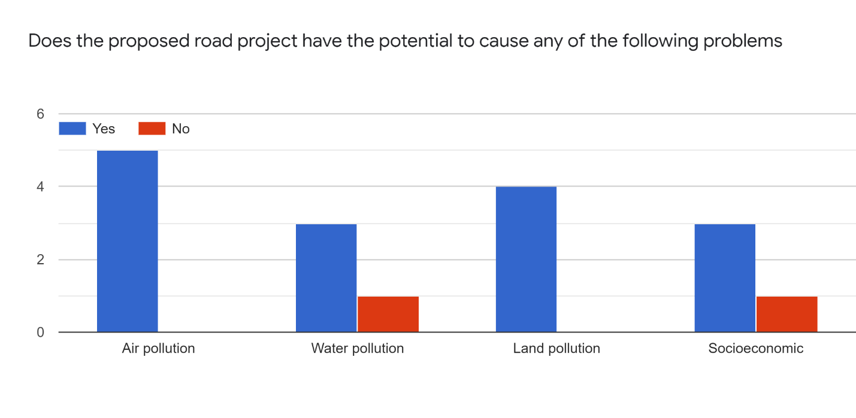

Figure 6: Community views on problems posed by the road project

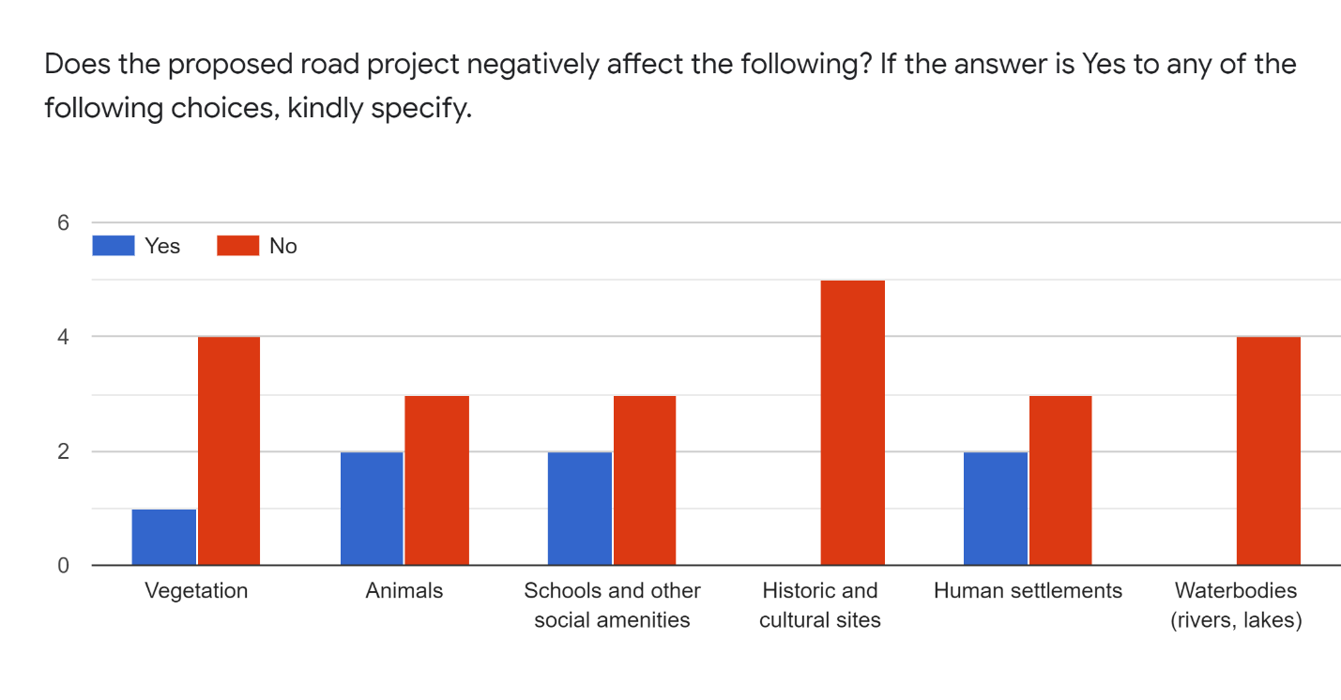

Figure 7: Community perceptions of the most sensitive areas to be impacted

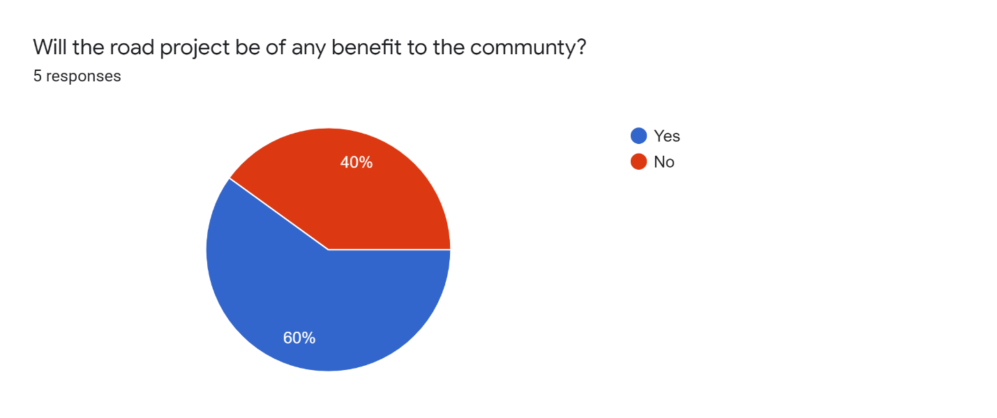

Figure 8: Opinion of the community to the road project

# ENVIRONMENTAL AND SOCIAL IMPACTS

## 5.1. Introduction

Implementation of development projects leads to obvious impacts due to change of state of the site. The impacts accrued are both positive and negative. The purpose of this environmental plan is to mitigate the adverse impacts during the construction, operation and decommissioning stages of the proposed road route.

## 5.2. Construction Phase

Road constructions are accompanied by a wide variety of activities such as mapping and placement of beacons, clearing of vegetation along the road, excavation, drilling of rocks on site, sometimes road projects may lead to displacement of human beings, thus necessitating resettlement. All these activities lead to a variety of impacts to the biotic and abiotic environment and human beings found on site. Thus, a robust environmental management and monitoring plan is needed in order to come up with a proper mitigation plans.

### Positive Impacts

#### Employment opportunities

The proposed road construction will create job opportunities to the local community since according to the law semi-skilled labour/casual work should be given to the local community so that they can benefit from the project directly. Employment of the local community will lead to acceptability of the project. This will minimize the possibility of conflict between the developer and the locals community.

#### Improved livelihood

The livelihood of the local community will improve due to increased income as a result employment, development of infrastructure which will lead to creation of more public utilities, social amenities, improved literacy and robust economic development of the area.

#### Infrastructural development

The proposed road will open up the area to an influx of population, this will lead to development of more social amenities such as construction of schools, hotels, malls,business centres, health centres, worship centres e.t.c.

#### Business development

Small scale businesses such as food kiosks and those selling wares will be established during the construction phase. These will boost the existing businesses in the area as well as providing a source of income to the jobless.

### Negative Impacts

#### Air pollution/Dust

The proposed road construction will cause air pollution because of dust from the excavation activities and movement of the construction machinery. This will cause discomfort to the nearby residents and workers, and additionally, respiratory and eye complications hence should be mitigated.

##### Suggested Mitigation

* Limit traffic speed to minimize dust generation.
* Regular servicing of vehicles and machinery to reduce exhaust emissions.
* Provision of dust masks for road construction workers.
* Trucks transporting the excavated soil from the site should be covered in tarpaulin to prevent emission of fugitive dust.
* Spraying of water on loose soil to increase compaction and minimize formation of fugitive dust

#### Water pollution

The proposed road project passes through River Kandisi. It is highly likely that River Kandisi will be polluted from siltation emanating from excavation activities.

##### Suggested Mitigation

* Hazards and toxic waste materials should be managed according to the international standards and practices and comply with local regulations as well.
* The operation should minimise close contact to River Kandisi as much as possible.
* The company must provide eco-toilets or portable toilets for the workers to minimize surface water and ground water pollution

#### Soil Pollution

The excavation will remove the topsoil layer and deposit it at a site to be identified. The exposed soil is susceptible to abrasion or erosion by wind and water agents. Wind abrasion will blow the loose soil to fugitive-dust, while erosion by water will clog waterways..

##### Suggested mitigation

* Construct gabions along gullies.
* Transport corridors should be detoured in a manner to avoid damage to trees and vegetation as much as possible.

#### Terrestrial Environment: Flora and Fauna

Soil excavation, vibration from heavy machinery and clearing of vegetation will have an impact to the existing flora and fauna and the wider ecosystem. This includes destruction of habitats, wildlife grazing pastures and behavioural change in wildlife species such as zebras, lions, gazelles and monkeys.

##### Suggested Mitigation

* Develop reasonable measures to protect existing vegetation cover as much as possible.
* Use of bulldozers on steep slopes and ecologically sensitive areas.
* Minimize contact with critical habitats such as foraging sites, roosting sites, nesting sites, dry season grazing grounds.
* Minimize noise and vibrations levels to avoid causing undue stress on wildlife.

Noise and vibrations

The use of heavy road construction and exploration machinery may generate excessive noise and vibration during the construction exercise.

##### Suggested mitigation

* Provide full protective gear for workers like helmets and ear muffs.
* Use local leaders to sensitize the neighbouring community about the project and its possible noise and vibration impacts.
* Monitor noise levels during the survey.

#### Noxious gases and offensive odours

Offensive odours maybe limited in a spatial extent and would be related to sanitation and combustion of fossil fuels expected from the construction and exploration machinery

##### Suggested Mitigation

* Put in place proper sanitation facilities for workers such as eco-toilets that are odourless..
* Solid wastes should be disposed in a sanitary manner and collected on regular basis by an authorized solid waste collector.
* Ensure the vehicles and equipment with defective exhaust are repaired.

#### Solid wastes and chemical spills

The mobilization and operation of the proposed project is expected to generate solid waste due to the expected human influx and activities. Some of the very likely waste material to be generated include cans, wrappings, paper and plastic waste among others at the base camps.   
Waste oils and petroleum used in vehicles and exploration machinery may spill or leak on/into the ground hence into the soil or water system within the project area.

##### Suggested mitigation

* Practice waste segregation and recycling of useful materials.
* Ensure that solid wastes are disposed in a designated area.
* Oil drip traps should be regularly maintained for a maximum performance particularly in the garage area.
* Regular servicing of equipment should be carried out with oil drip trap.

#### Health and Safety Impacts.

Due to the nature of the proposed project, Operational, Safety and Health (OSH) risks of the workers and residents will increase.

##### Suggested Mitigation

* Avoid building the base camps in close proximity to human settlements.
* Workers are to follow best OSH practices while working, including wearing eye and ear protective gear and reflector jackets.
* Cleanliness and tidiness should be maintained at the workers’ quarters to minimize spread of waterborne or respiratory diseases.
* Health and safety of neighbouring communities should be assured through safe operating practices by workers and restrictions on activities that generate loud noise.

#### Social Impacts

The project will increase the number of people in the area. Possible negative implications include prostitution, drugs peddling and disruption of the inherent pastoral lifestyle in the area.

##### Suggested mitigation

* Creation of awareness to the public by the social welfare team of the company in partnership with the local authority.
* Creation of a communication office based at the project site during the construction phase.

## 5.3. Operational Phase

After the company clears up from the project site on completion then the road will be opened for use by the public. This phase will bring some positive but also negative impacts. Below is a list of the impacts and proposed mitigation measures.

### Positive Impacts

The local community outlined the following issues as the possible short-term and long-term positive impacts of the proposed road route in the area

* The project will create job opportunities.
* The road will ease transport in the area hence the community will benefit from the road directly.
* The project will catalyse development opportunities in the area thus helping in fighting poverty and thus improve the livelihoods in the area.
* The project will boost the economy of the area and the country at large upon completion.
* The project may catalyze the entry of other technologically sophisticated industries, such as communication companies into the area.
* Skills transfer to the local community will be an added advantage.
* Local tourism will develop as a result of the road because the area is a wildlife corridor.
* Creation of social recreational amenities such as sport areas, hotels, and streets lights will improve the quality of life of the residents along the proposed route.

### Negative Impacts

#### Accidents

There will be an increased risk of traffic accidents due to the rise of vehicular traffic. This will be a risk to the human, livestock and wildlife in the area.

##### Suggested mitigation

Creation of bumps, visible road signs and zebra crossing points along the sensitive areas such as market centres, livestock and wildlife crossing areas to minimize the road accidents.

#### Air pollution

Vehicular fumes from moving traffic will cause discomfort, and respiratory and eye irritation.

##### Suggested mitigation

#### Water pollution

The proposed road project crosses River Kandisi. There is a likelihood that the drainage channels may accumulate solid waste which will be dumped into the river. This will pollute the river and make it unsuitable for consumption by wildlife within Nairobi National Park.

##### Suggested Mitigation

* Install drainage channels on roads where natural drainage maybe a challenge.

#### Terrestrial Environment: Flora and Fauna

Increase of population will increase the automobile services in the region. This will have an impact to the existing flora and fauna and the wider ecosystem such as change in wildlife behaviour and migratory patterns and routes.

##### Suggested Mitigation

* Develop reasonable measures to protect existing vegetation cover as much as possible.
* Minimize contact with critical habitats such as foraging sites, roosting sites, nesting sites, dry season grazing grounds.
* Put up wildlife signages to indicate to motorists that they are approaching a wildlife migratory corridor

#### Social Impacts

The project will increase the number of people in the area and possible negative implications include prostitution, child labour, child abuse, drugs peddling, disruption of the inherent pastoral lifestyle in the area.

##### Suggested mitigation

* Creation of awareness to the public by the social welfare team of the company in patnerhip with the local authority.
* Installation of traffic lights.

## 5.4. Decommisioning Phase

This is the end life of a project. When the life span of a road is over and it serves no other useful purpose, it is decommissioned. The purpose of decommissioning is to transform the project site to a new land use, or restore the area to its previous baseline conditions. The decommissioning process has a variety of activities which will bring about both positive and negative impacts.

### Positive impacts

#### Employment opportunities

The proposed road demolition will create job opportunities to the local community. According to the law semi-skilled labour/casual work should be given to the local community so that they can benefit from the project directly. Employment of the local community will lead to acceptability of the project. This will reduce the possibility of conflict between the developer and the local community.

#### Business development

Business hubs will develop along the road during the decommissioning phase. For example, catering services.

### Negative Impacts

#### Air pollution/Dust

Fugitive dust will be generated from the excavation activities and movement excavation machinery. This will cause eye and respiratory irritation to nearby residents.

##### Suggested Mitigation

* Contractor must use well-serviced equipment to reduce exhaust emissions.
* Provision of dust masks for workers involved in the decomissioning phase

#### Water pollution

The proposed road project passes through River Kandisi. Excavation activities in the decommissioning phase might increase the river’s sediment load. There might be a possibility of dumping of waste in the river which will make the water unsuitable for consumption by wildlife in the National Park.

##### Suggested Mitigation

* The operation should minimise close contact to River Kandisi as much as possible.
* The company should consider to construct pit latrines or portable toilets for the workers.

#### Soils

Excavated activities often produce soil heaps and open pits. The exposed loose soil in soil tailings is susceptible to abrasion and erosion by wind and water. Fugitive dust will be formed by the action of wind on loose soil while the erosive action of water will deposit the eroded material from soil heaps on waterways.

##### Suggested Mitigation

* Construct gabions along gullies.
* All excavated material must be collected as soon as possible and used to rehabilitate open quarries within the vicinity.

#### Terrestrial Environment: Flora and Fauna

Soil excavation, vibration from heavy machinery as well as clearing of vegetation will have an impact to the existing flora and fauna and the wider ecosystem. Increased human activity at the decommissioning stage might alter wildlife behaviour, or cause stress which might increase human-wildlife conflicts.

##### Suggested Mitigation

* Develop reasonable measures to protect existing vegetation cover as much as possible.
* Use of bulldozers on steep slopes and ecologically sensitive areas.
* Minimize contact with critical habitats such as foraging sites, roosting sites, nesting sites, dry season grazing grounds.
* Measures to minimize noise and vibrations levels in the project areas should be employed in order to cause the least possible destruction.
* Monitor noise levels during the operation.

#### Noise Pollution

Decommissioning of construction structures involve noisy activities originating from  
movement of heavy ground vehicles, disassembling all the prefabricated structures,  
disconnection of services, breaking down concrete foundations and handling of debris from  
sites. Though short lived, the generated noise will affect exposed workers and, in some cases,  
the nearby communities.

##### Suggested mitigation

* Monitor noise levels as per the NEMA Environmental Management and  
  Coordination (Noise and Excessive Vibration Pollution) (Control) Regulations,  
  2009 & OSHA, 2007;
* The noise emission characteristics should be considered during selection and  
  mobilization of decommissioning equipment

#### Land dereliction

The decommissioning of the road may involve demolition from the surface grade (tarmac) to the base grade. This will cause deposition of heaps of debris composed of asphalt blocks and exposed rocks (from base grade). Where the road will be covered with soil to transform to a new land use, soil heaps will reduce the aesthetic appeal of the land.

##### Suggested mitigation

* The contractor involved in the decommissioning phase to hire the services of professional waste collectors.
* The debris and excavated rocks forming the base grade are to be used fill quarries or form base grades for a new road construction project.

Table 2: Environmental and Social Management Plan (ESMP)

| Category of impact | Affected environmental parameter | Effects/consequences | Mitigation Actions |
| --- | --- | --- | --- |
| Construction | | | |
| Excavation | Air quality | Dust and vehicular fumes | * Limit traffic speed to minimize dust generation * Regular servicing of vehicles and machinery to reduce exhaust emissions. * Provision of dust masks for construction workers * Spraying of water on loose soil to increase compaction and minimize formation of fugitive dust |
| Water Pollution | Water quality of river Kandisi | Water pollution  Water contamination | * Hazards and toxic waste materials should be managed according to the international standards and practices and comply with local regulations as well. * minimise close contact to River Kandisi as much as possible. * Provision of eco-toilets for the workers to minimize contamination by faecal matter on surface and groundwater sources |
| Soil Pollution | Top soil and sub-soil | Formation of fugitive dust  Siltation in rivers | * Construct gabions along gullies * Transport corridors should be detoured in a manner to avoid damage to trees and vegetation as much as possible. |
| Ecological disturbance | Fauna and Flora | Destruction of bird/avian habitats, wildlife grazing pastures and change in wildlife behaviou | * Develop reasonable measures to protect existing vegetation cover as much as possible. * Use of bulldozers on steep slopes and ecologically sensitive areas * Minimize contact with critical habitats such as foraging sites, roosting sites, nesting sites, dry season grazing grounds. * Minimize noise and vibration levels to avoid causing undue stress on wildlife |
| Noise pollution | People and wildlife | Increased animal stress | * Provide full protective gear for workers like helmets and ear muffs. * Use local leaders to sensitize the neighbouring community about the project and its possible noise and vibration impacts. * Monitor noise levels during the survey. |
| Noxious gases and offensive odours | Base camps | Discomfort | * Put in place proper sanitation facilities for workers such as eco-toilets that are odourless. * Solid wastes should be disposed in a sanitary manner and collected on regular basis by an authorized solid waste collector. * Ensure the vehicles and equipment with defective exhaust are repaired. |
| Solid wastes and chemical spills | Land | Water pollution  Groundwater contamination | * Ensure that solid wastes are disposed in a designated area. * Oil drip traps should be regularly maintained for a maximum performance particularly in the garage area. * Regular servicing of equipment should be carried out with oil drip trap. |
| Health and Safety Impacts | Workers and nearby residents | Spread of diseases | * Avoid building the base camps close to human settlements * Workers are to follow best OSH practices while working, including wearing eye and ear protective gear and reflector jackets. * Cleanliness and tidiness should be maintained at the workers’ quarters to minimize spread of waterborne or respiratory diseases. * Health and safety of neighbouring communities should be assured through safe operating practices by workers and restrictions on activities that generate loud noise. |
| Social impacts |  | Prostitution, drugs peddling | * Creation of awareness to the public by the social welfare team of the company in partnership with the local authority. * Creation of a communication office based at the project site during the construction phase. |
| Operation phase | | | |
| Accidents | Pedestrians and drivers. | Death, injuries and Disability Adjusted Life years (DALYs) | * Creation of bumps, visible road signs and zebra crossing points along the sensitive areas such as market centres, livestock and wildlife crossing areas to minimize the road accidents. |
| Air pollution |  | Discomfort,  Eye and respiratory irritation | * Regular servicing of vehicles and machinery to reduce exhaust emissions. |
| Water Pollution | River Kandisi | -Blockage of the road ditches/stormwater drainage  -Contamination and increase solids in the river | * Install drainage channels on roads where natural drainage maybe a challenge. |
| Ecosystem disturbance and stress to wildlife | Fauna and flora | Change in wildlife behaviour | * Develop reasonable measures to protect existing vegetation cover as much as possible. * Minimize contact with critical habitats such as foraging sites, roosting sites, nesting sites, dry season grazing grounds. * Install signages to indicate to motorists that they are approaching a wildlife migratory route. |
| Social Impacts | Community | Prostitution, car jacking | * Installation of traffic lights |
| Decommissioning | | | |
| Air Pollution | Air quality | Eye and respiratory irritation and complications | * Contractor must use well-serviced equipment to reduce exhaust emissions * Provision of masks for workers involved in the decommissioning phase * Sprinkling of water on loose soil to increase compaction and minimize formation of fugitive dust |
| Noise pollution | Workers and community | Discomfort to the community | * Monitor noise levels as per the NEMA Environmental Management and Coordination * The noise emission characteristics should be considered during selection and mobilization of decommissioning equipment |
| Land dereliction | Land | Formation of fugitive dust  Land dereliction and loss of aesthetic value | * The contractor involved in the decommissioning phase to hire the services of professional waste collectors. * The debris and excavated rocks forming the base grade are to be used fill quarries or form base grades for a new road construction project |

# ENVIRONMENTAL AND SOCIAL MONITORING PLAN

## 6.1. Introduction

Monitoring of a road project is important as it helps to identify when impacts are approaching a critical point that will be detrimental to both the project and the users. Monitoring helps in identifying project activities that require immediate attention, understand the cause-effect relationship of impacts, and quantify the level of impacts to human beings and the environment (Otieno Odongo & Partners Consulting Engineers, 2016).

Regarding the Ongata Rongai – Kitengela project, monitoring will help ensure that the construction and operation phases meet safety and quality standards both for the worker and road user. Baseline conditions of water, air, noise and vegetation species will be collected before project commencement to act as a reference during construction and operation phase monitoring stages.

Both compliance and effect monitoring will be conducted on the road project. Compliance monitoring refers to checking if prescribed actions regarding a project have been implemented. Conversely, effect monitoring refers to checking the consequences of activities, mainly through physical measurements. Compliance monitoring will focus on living conditions and work procedures such as PPEs, workers’ quarters, permits etc. Effect monitoring will focus on environmental variables such as water, soil and air quality.

Glasson (1978) outlines the seven components that are necessary in a monitoring report (Glasson, 1978). Out of this list, three components have been used in creating this project’s monitoring plan and they are:

* Monitoring arrangements for each mitigation measure
* Person or agency responsible for the mitigation measure monitoring
* Timing and/or frequency for the monitoring

## 6.2. Purpose of monitoring

The proposed Ongata Rongai – Kitengela road will be monitored to fulfil the following purposes:

* To ensure that the road construction processes meet the correct specifications
* To identify cause-effect of problems which helps in avoiding future calamities
* To determine if the road is efficiently handling the work it was initially designed for.
* To identify the underlying factors invisible to the naked eye that may contribute to road failure
* To assess the progress of the project according to assigned timelines
* To identify at what point construction and operation activities contravene environmental and social safeguards

## 6.3. Construction phase

Monitoring at the construction phase is to establish the pollution levels that arise from construction activities. The construction phase is the most destructive stage in the entire life cycle of a road. The following parameters will be measured during the construction phase.

**Water quality** – it is important to ensure that the construction does not contribute to water pollution through soil erosion, and chemical leaks. Monitoring will identify whether the road project is responsible for a significant increase in water pollutants along the rivers, if this does occur.

**Air quality** – air quality is negatively affected by elements such as smoke, dust, and fumes. All these emissions are generated from machine operations that emit vehicular fumes or loosening the soil structure, making it susceptible to be easily blown by wind. Monitoring of air quality in a construction project will help mark the point at which particulate matter exceeds the recommended air quality standards.

**Noise levels** – vehicular movement and excavation activities generate noise. Excessive noise causes lack of concentration, stress and impaired judgements. Monitoring will help keep construction activity below the prohibited noise limits.

**Loss of biodiversity** – for purposes of site clearance and to gain appropriate width of the road pavement, vegetation is normally eradicated. The vegetation most affected in a road construction project is that along the road path and next to the road shoulders. Through monitoring, the vegetation species and the number of trees to be replanted along the route will be quantified.

**Frequency of illness** – rapid spread of diseases occurs in enclosed spaces or densely packed settlements. Construction camps are at high risk due to the high number of personnel housed in a single dwelling space. Monitoring will help in early detection of disease among the workers before it generates to a full-blown epidemic.

**Operational Safety and Health** – accidents and injuries are prone to happen if safety regulations are not keenly followed. Monitoring will be used to assess the causes and common types of accidents or injuries.

**Insecurity** – the lack of or sign of proper vigilance can be assessed by the number of theft cases being reported to the construction authorities. In a place where there is sufficient security at the construction site, theft cases are non-existent. Monitoring will be used to ascertain the overall level of security to the road project components and labour.

## 6.4. Operation phase

At the operation phase, the road is being utilized for its purpose. That is, the enhancement of transportation of people, animals, goods and services. At the operation phase, there is minimal monitoring activity compared to the construction phase because transport costs impede frequent visitations to collect environmental and social parameters. At this second phase of the project, monitoring will assess the impacts that may arise because of normal use of infrastructure and maintenance activities.

The following are the environmental and social factors to be monitored.

**Tarmac quality** – The topmost surface of a road that withstands abrasion, erosion and friction is known as surface grade. Regular monitoring checks will ascertain when and where the surface grade needs recarpeting or rehabilitation. Monitoring will also check the visibility of traffic lines and where they need repainting.

**Road ditches** – these are susceptible to siltation from overland flow, which deposits loose soil from unpaved surfaces after a precipitation event. Monitoring visits will locate points along the road ditch that need unblocking, which is a major cause of road floods.

**Traffic density** – visual inspection will check the number of cars per hour plying along the route. Monitoring of traffic activity will confirm if the road is serving its target population, which should reflect in the number of vehicles using the route.

**Road safety** – this refers to the safety and security issues, positive or negative, the road is associated with. Road safety can be assessed using common variables such as number of accidents or security threats. Monitoring of these cases will identify the major cause factors for the negative issues.

## 6.5. Decommissioning phase

The lifespan of most roads is 15 years. Monitoring of the road at this phase will be conducted during the decommissioning activity which includes conversion of the road to a former or new land use.

The variables to monitored at this stage are similar to those in the construction phase. Specifically, they are air quality, noise levels, OSH, and loss of biodiversity.

Table 3: Environmental and Social Monitoring Plan (ESMoP) Table

| Parameter | Location/sampling site | Indicator | Monitoring frequency | Measuring unit | Responsible actor |
| --- | --- | --- | --- | --- | --- |
| Construction | | | | | |
| Water quality | At River Kandisi | Turbidity | Weekly | Nephelometric Turbidity Units (NTU) | Contractor |
| Air quality | Along the route | Particulate matter (PM) concentration | Weekly | Particulate Matter concentration | Contractor |
| Noise levels |  | Number of complaints from workers and residents | Daily | Decibels | Contractor |
| Loss of biodiversity | Road shoulders | Felled trees, destroyed vegetation | Daily | Number and species of vegetation | Contractor |
| Frequency of illness | Camp site/workers quarters | Number of disease cases reported/confirmed | After two weeks | Infection rate (%) of the total | Project proponent |
| Operation safety and health risk factors | Site of operations | Number of accidents/injuries reported | Daily | - | Contractor |
| Insecurity |  | Frequency of reported theft cases/insecurity | Weekly | - | Administrative Police and Contractor |
| Operation phase | | | | | |
| Tarmac quality | At intermediate points after a certain distance | Cracks, fading of traffic separator lines | Annually | - | Kenya Rural Road Authority (KeRRA) |
| Road ditches | At intermediate points | Silt deposition, collapse of ditches | Annually | - | KeRRA |
| Traffic density | At specific points | Movement of vehicles | Bi-annually | Number of vehicles per hour along a section of the route | KeRRA |
| Road safety |  | Frequency of reported accidents, insecurity cases such as carjacking incidents | Annually | - | KeRRA, National Transport and Safety Authority (NTSA) |

# PROJECT ALTERNATIVES

## 7.1. Alternative routes

There are no existing alternative routes that could potentially serve the same purpose as the proposed road. Development of any routes apart from the existing murram road will face ecological and economic impediments. For example, the proposed road project is bordered by Nairobi National Park (NNP) to the North, and by private ranches and plots to the south. The National Park is a wildlife protection zone, and it is highly unlikely, not less permissible for any man-made infrastructure to pass through the park. The building of the Standard Gauge Railway (SGR) across the park required equal land compensation elsewhere per acre of land passed through by SGR in the park. The construction of a road through NNP would severely affect the biodiversity and wildlife ecosystems in the park. Developing a road infrastructure through the individual plots to the south will greatly increase project costs due to the need for land compensation and resettlement of Project Affected Persons (PAPs).

After cost-benefit analysis of the above two proposals, the current road route is the cheaper, environmentally safer, and most feasible option.

## 7.2. Alternative road construction activities and technology

The proposed road project involves upgrading the murram route to a bituminous road. The contractor must use construction machines in good condition to minimize air pollution and repair costs. Two bridges should be constructed—to upgrade the existing one over River Kandisi and a newly-built one over the unnamed stream. The bridges will prevent flooding over the road during precipitation events.

Just like the drainage design along Southern Bypass, V-shaped drainage channels overlain with concrete tiles should be built on the road shoulders to direct overland flow to rivers. Where trees will be felled to for site clearing during the construction phase, they should be replaced with indigenous species of the area. This report strongly discourages using the felled trees for any construction activity as it may justify indiscriminate logging for construction purposes. The contractor will follow the alignment of the murram road throughout the route to prevent any damage to property or natural ecosystems.

## 7.3. Justification

The proponent (Government of Kenya) has settled on the current route because of the following reasons:

1. It is already a relatively clear road reserve, ie. No additional site clearing is needed except for excavation purposes. This limits vegetation clearing to only those areas adjacent to the road shoulders.
2. The availability of a relatively clear road reserve greatly reduces land compensation and resettlement packages. This is because the road route does not pass through individual land property, except where encroached upon.
3. The road already has moderate vehicular traffic. This means that some road users are already aware of the road’s existence.
4. The road route will shorten the distance of vehicles travelling to Ongata Rongai, Kiserian and Narok from Mombasa road. This will reduce unnecessary vehicle traffic within Nairobi Central Business District (CBD) for motorists heading to these destinations.

The current route is economically, socially, and environmentally feasible. The proposed Ongata Rongai – Kitengela route halves the distance between the two towns, from 46km to 26km. It will also boost local tourism within the area. Taking advantage of the route’s proximity to NNP, a few tourist resorts have been built along the road, such as Cockpit hotel. The tarmacking of the route will improve accessibility to such tourism resorts and to Tuala centre, thus improving businesses. Currently, the murram along the route is susceptible to both wind and water erosion. It is dusty during dry weather and muddy after precipitation events. The status quo is an inconvenience to the business operations, travel experience and health of pedestrians plying along the route.

The advantages of tarmacking the route will outweigh the disadvantages. Motorists will save on transport costs and travel distance. At a larger scale, business will benefit from improved market accessibility while residents and pedestrians will be at less risk of contracting respiratory diseases as a result of wind-blown dust.

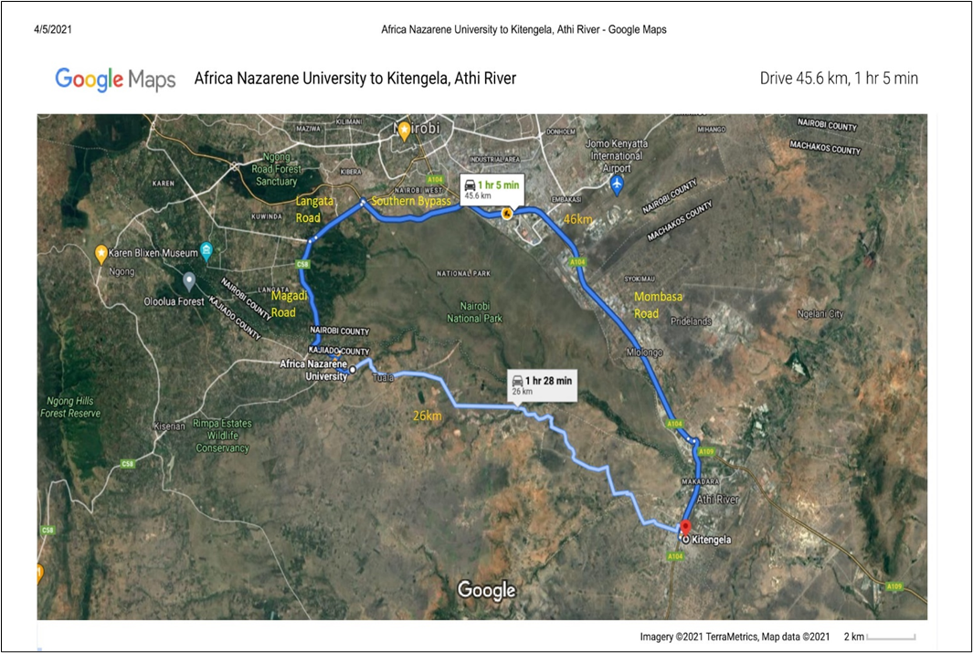

Figure 9: Route of the proposed road compared to the current route

# CONCLUSION AND RECOMMENDATIONS

The current road route was arrived at after consideration of the available environmental, social and economic conditions. Possible alternative options were considered, but the current route was cheaper and less damaging to the environment. According to this ESIA report, the construction and operation phases will have the highest environmental and social impacts. The impacts are as follows: dust and air emissions, noise pollution and vibration, clearing of vegetation, change in hydrology, soil erosion (excavation and earthworks), human-wildlife conflict, loss of wildlife due to accidents, pollution of soil and water sources from spillage/leakage of oils and sediment loading, disposal of solid and liquid wastes. The occupational health and safety issues identified include accidents and hazard risks during construction, possible exposure of workers to diseases, risks posed to communities living in the area including injuries and accidents, spread of communicable diseases, social and cultural change because of labour influx and immigrants in the area, and increased loss of human and livestock life due to road accidents. However, mitigation measures have been proposed for all identified impacts, and an environmental and social management plan has been prepared. Mitigation measures will be included in the Bill of Quantities, conditions of contract, and technical specifications for the road.

Recommendations

Recommendations for the prevention and mitigation of adverse impacts are as follows:

* The project should involve the stakeholders and public during the project implementation, and particularly during the construction and early stages of the road use to ensure minimized environmental and social impacts.
* The Contractor should develop a Contractor’s environment and social management plan (CESMP) in line with this ESIA report for purposes of supervision and continuous monitoring.
* Appropriate safety audit should be undertaken for the road to guide on the implementation of safety measures during construction and operation stages.
* Continuous stakeholder engagement of the road users and community members on safety will be necessary in the long-term management of the road section.
* The project should ensure that the contractor comply with the requirements of the ESMP, which includes compliance with all the environmental and social mitigation measures, and other requirements.
* Periodic environmental and social monitoring is important to ensure that measures proposed in this ESIA have been implemented to mitigate or avert any negative impacts for the project.
* KeRRA and the contractor should set up proper and applicable Grievance Redress Mechanism (GRM) for the project to deal with grievances and issues raised during the implementation of the project.

# References

Glasson, J. (1978). Life after the Decision: The Importance of Monitoring in EIA. *Built Environment, 20*(4), 309-320. Retrieved from http://www.jstor.org/stable/23287803

KNBS. (2019). *2019 Kenya Population and Housing Census Volume 1: Population by county and sub-county.* Nairobi: Kenya National Bureau of Statistics. Retrieved from https://www.knbs.or.ke/?wpdmpro=2019-kenya-population-and-housing-census-volume-i-population-by-county-and-sub-county&wpdmdl=5615&ind=Vk9MVU1FIDEgS1BIQyAyMDE5LnBkZg

Matheson, F. (1966). *Geology of the Kajiado area.* Nairobi: Ministry of Natural Resources and Wildlife. Retrieved from https://edepot.wur.nl/485250

NEMA. (2009). *Kajiado District Environment Plan (2009 - 2013).* Nairobi: Government of Kenya. Retrieved from https://www.nema.go.ke/images/Docs/Awarness%20Materials/NEAPS/kajiado.pdf

Otieno Odongo & Partners Consulting Engineers. (2016). Environmental and Social Impact Assessment Report for the Proposed Upgrading of the Nyigang'-Lokiror-Lokichar Road (C113/C46) to Bitumen Standards. Nairobi.

Saggerson, E. (1991). *Geology of the Nairobi Area.* Nairobi: Ministry of Environment and Natural Resources. Retrieved from https://s3-eu-west-1.amazonaws.com/samsamwater1/maps/kenya/geology/Geology+of+the+Nairobi+area.pdf

# APPENDICES

## Appendix 1: Baseline Data Collection Form

| Baseline Condition | Factors to be assessed | Results/Findings |
| --- | --- | --- |
| Physical | | |
| Topography | What is the topography of the area? Give a range of the altitude limits of the area. |  |
| Give a description of the terrain of the area—gentle or steep slope, flat or hilly/undulating |  |
| Is there any soft ground on the route that may cause slope failures or landslides? |  |
| Geology | What are the rocks types inherent in the area? |  |
| What is the stratigraphy of the rocks in the area? |  |
| What is the seismic history of the area? What seismic events have happened in the past i.e earthquakes, eruptions? |  |
| Climate | Identify the maximum, minimum and average temperatures |  |
| Describe the months with the highest and lowest temperatures |  |
| Distribution of temperature in the area.  Identify the limits of rainfall amounts and their distribution within the year. |  |
| What is the humidity of the area |  |
| Soil types | What is the classification of the soils in the area? |  |
| What is the level of water-holding capacity of the soil? |  |
| What is the texture of the soil? |  |
| Can the soils support agriculture? What use are they best for? |  |
| Hydrology | Name the lakes and rivers in the area, if any. |  |
| Classify the lakes and rivers ie. Fresh or salty/brackish, permanent, seasonal or intermittent |  |
| How deep are the aquifers in the area? |  |
| What are the types of the aquifers in the area? Are they confined or unconfined? |  |
| Is there a possibility that alteration of topographic features and installation of structures, such as tunnels will adversely affect surface water and groundwater flows? |  |
| Biological | | |
| Flora | Name the vegetation species in the area? Which vegetation species are endemic or widespread? |  |
| Fauna | Name the fauna species in the area. Identify the endemic |  |
|  | Identify the wetlands in the area, if any |  |
|  | Does the project site encompass primeval forests, tropical rain forests, ecologically valuable habitats (e.g., coral reefs, mangroves, or tidal flats)? |  |
| Pollution | | |
| Air quality | Does ambient air quality comply with the country's air quality standards |  |
| Water quality | Are the water bodies safe for human consumption? |  |
| Socio-economic | | |
| Demography | What is the population of the area to the lowest administrative unit in the 2019 census? |  |
| Level of education according to the 2019 census. |  |
| Infrastructural | List the social amenities present in the area. |  |
| What amenities does the area lack? |  |
| Describe the roads in the area. What classes of roads exist in the area? Class A, class B, primary, secondary, tertiary? |  |
| Describe sanitation and sewage disposal in the area |  |
| Main economic activities of the area according to the 2019 census. |  |
| Observe the level of vehicle traffic volumes at important road intersections.eg. type of vehicles frequent along the route. |  |
| Economic | What unexploited natural resources does the area have? |  |
| What kinds of assets are along the road route eg. houses, private lands etc |  |
| Cultural | | |
|  | Is there a possibility that the project will damage the local archaeological, historical, cultural, and religious heritage? |  |
|  | Are adequate measures considered to protect these sites in accordance with the country's laws? |  |

## Appendix 2: Road Questionnaire

**Questionnaire Environmental Impact Assessment**

**Background information**

1. Gender: Male **[ ]** Female **[ ]** Prefer not to say **[ ]**
2. Education: Primary **[ ]** Secondary**[ ]** College**[ ]**
3. Age: 18-25 **[ ]** 26-45 **[ ]** 45+**[ ]**
4. Occupation: employed **[ ]**  unemployed **[ ]** other **[ ]**

**Project information**

1. Has there been a road development project in your area recently?

Yes **[ ]** No **[ ]**

If yes what was the project?

_________________________________________________________

_________________________________________________________

1. Was the public consulted when the project started?

Yes **[ ]** No **[ ]**

If yes how was the Public informed of the project?

1. Broadcast media (television, local radio etc) **[ ]**
2. Print media **[ ]**
3. Local chief/ Barazas
4. Social media **[ ]**
5. Print notices **[ ]**
6. Community members/social groups/nyumba kumi/churches/mosques **[ ]**
7. Other **[ ]**
8. At what stage was the public informed of the project?

Planning and design **[ ]** implementation/ commencement stage **[ ]**

1. Have you been personally involved/consulted in an Environmental Impact assessment in your community?

Yes **[ ]** No **[ ]**

1. If Yes at what stage were you involved?

Planning and design **[ ]** implementation/ commencement stage **[ ]**

1. What were the key challenges that faced public consultation at the design and implementation stage? (At most two)

Lack of communication between the government and local community **[ ]**

Lack of transparency**[ ]**

Diverging opinions**[ ]**

Others (specify) _____________________________________________   
___________________________________________________________

___________________________________________________________

1. As a member of the local community, do you understand your role in the development project?

Yes **[ ]** No **[ ]**

If yes Kindly specify____________________________________________

____________________________________________________________

_____________________________________________________________

1. Does the proposed road project have the potential to cause any of the following problems.
2. Air Pollution Yes**[ ]** No **[ ]**

If yes, please specify__________________________________________

__________________________________________________________

__________________________________________________________

1. water pollution Yes **[ ]** No **[ ]**

If yes, Please specify_________________________________________

_________________________________________________________

_________________________________________________________

1. land pollution Yes **[ ]** No **[ ]**

If yes, Please specify_________________________________________

_________________________________________________________ _________________________________________________________

1. socioeconomic Yes **[ ]** No**[ ]**

If yes, Please specify_________________________________________

_________________________________________________________

_________________________________________________________

1. others (specify)_____________________________________________

_________________________________________________________ _________________________________________________________

1. Has the developer assisted in addressing the challenges

Yes **[ ]** No **[ ]**

If yes, please explain how_______________________________________   
___________________________________________________________

___________________________________________________________

1. Do you know of an alternative route the proposed road can pass through apart from the identified route?

Yes**[ ]** No**[ ]**

If yes, specify ______________________________________________

_________________________________________________________

_________________________________________________________

1. Does the proposed road project negatively affect the following? If the answer is Yes to any of the following choices, kindly specify.

Vegetation Yes **[ ]** No**[ ]**

Specify

Animals Yes **[ ]** No**[ ]**

Specify

Schools and other social amenities Yes**[ ]** No **[ ]**

Specify___________________________________________

Historic and cultural sites Yes**[ ]** No**[ ]**

Specify____________________________________________

Human settlements Yes**[ ]** No**[ ]**

Specify____________________________________________

Waterbodies (rivers, lakes) Yes**[ ]** No**[ ]**

Specify ___________________________________________

1. Will the road project be of any benefit to the community?

Yes **[ ]** No**[ ]**

If yes, can you list the benefit(s)?______________________________

________________________________________________________

________________________________________________________

________________________________________________________

________________________________________________________

________________________________________________________

Thank you very much!

## Appendix 3: Questionnaire Results

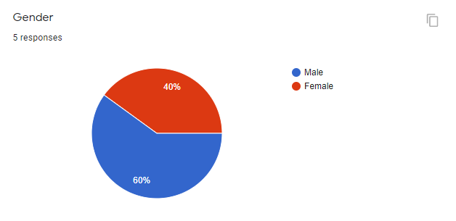

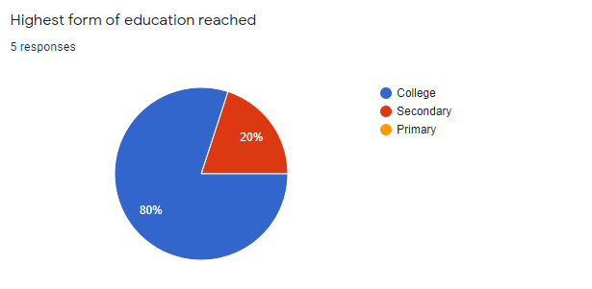

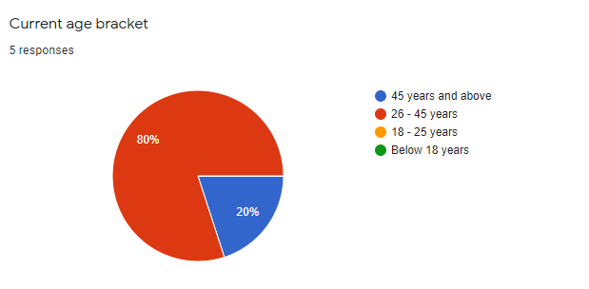

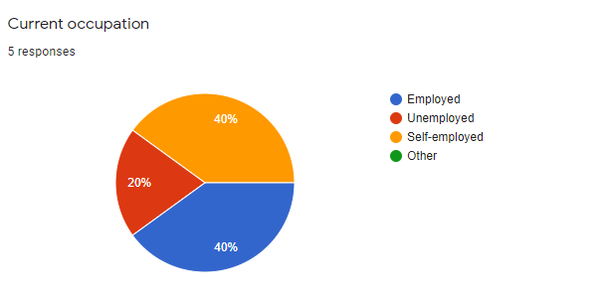

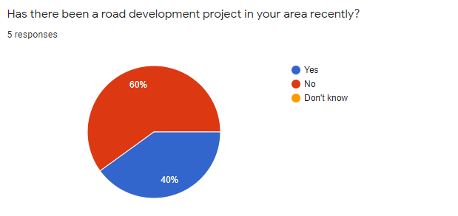

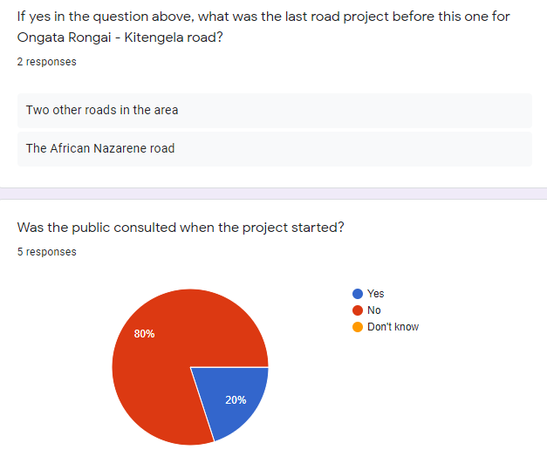

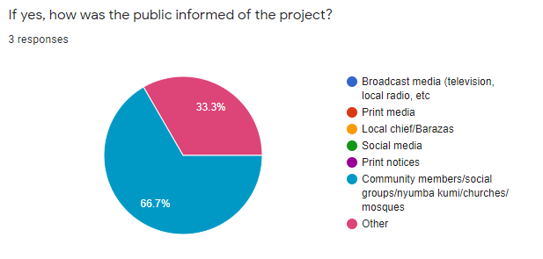

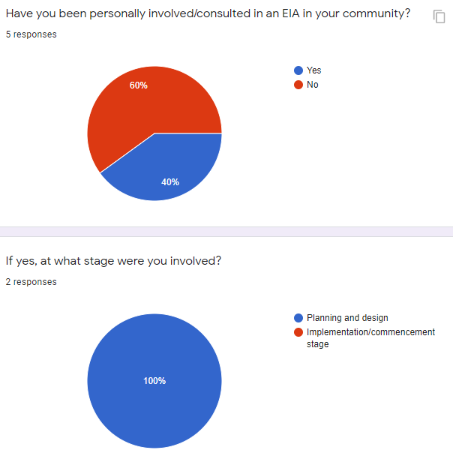

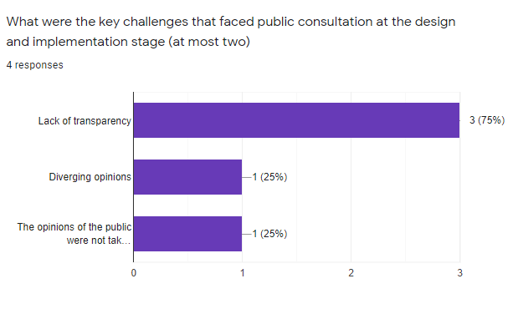

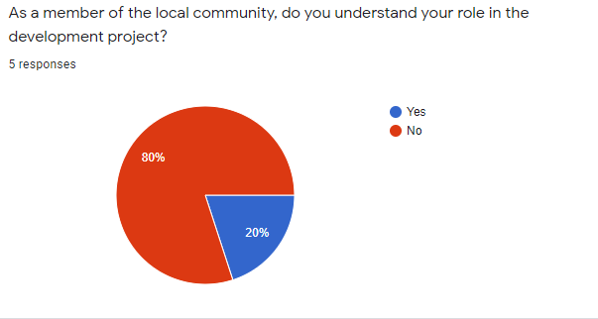

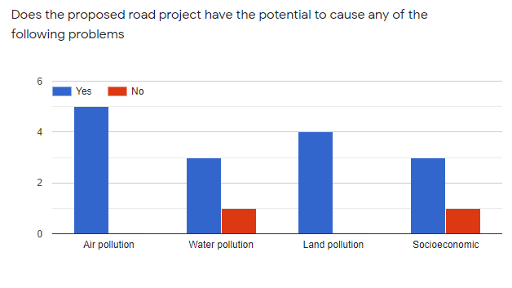

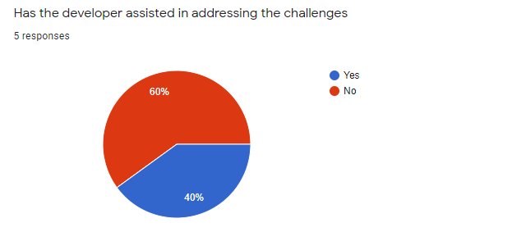

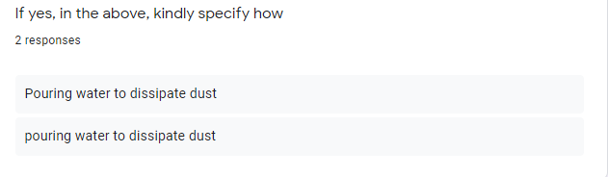

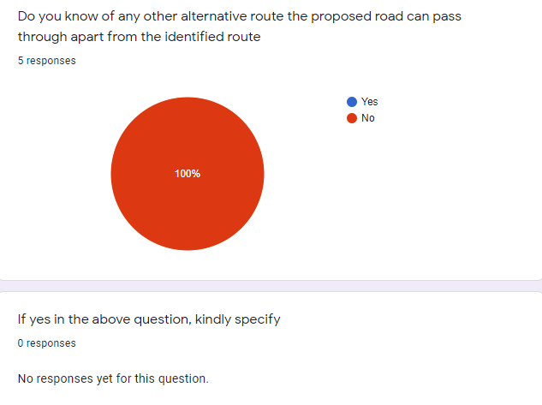

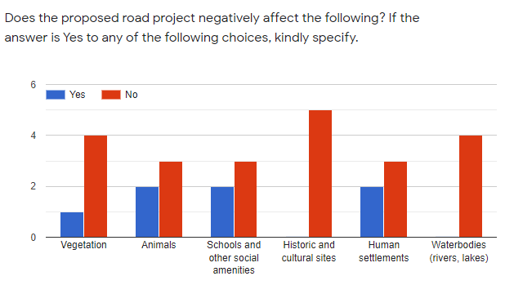

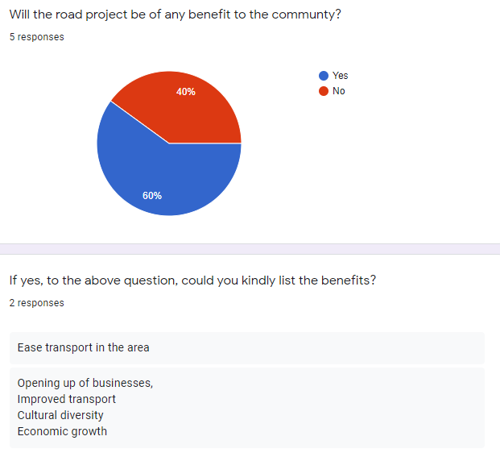

1. Group Leader